**Alexandra Sports Ground opened 27/12/1920**

**– a chronology of users and facilities**

**Acknowledgements:**

* Special thanks to Danny and Judy Barry whose passion for the history of Ararat motivated this compilation of events

**This chronology was compiled through resources supplied by:**

* Lorna Banfield collection at Ararat Library – a list of dates of events reported in the Ararat Advertiser
* Ararat Advertiser – archived issues of the Ararat Advertiser
* Ararat Municipal Library – archived issues of the Ararat Advertiser
* “From the Recreation Reserve to Kokoda Park, Ararat” by Danny and Judy Barry
* Ararat Advertiser articles related to Alexandra Sports Ground – compiled by Danny and Judy Barry
* Langi Morgala Museum – historical photos
* Trove – National Library of Australia, online digitised newspapers
* “Green Pastures and Gold: A history of Ararat” – by Lorna Banfield
* “Like The Ark: The history of Ararat” – by Lorna Banfield
* Joy Gunstone – information and dates about Ararat City Tennis Club
* Ararat Football Club – information from meeting minutes

***With the help of the public and new information the aim is to make this a more accurate document.***

*Ararat Advertiser Saturday April 5 1919*

**ARARAT NEW SPORTS GROUND - THE STATE PREMIER’S VISIT**

The State Premier, the Hon. H S W Lawson, MLA., who was received at the Town Hall on Wednesday evening last by the Mayor (Cr TJ Gossip) when on his way to the Hamilton district, expressed a keen desire to assist the Borough Council in every way possible in carrying out the proposal for a new sports ground abutting Alexandra Park on the west side. When the matter was mentioned, the Premier expressed a wish to see the plans of the scheme. These were produced by Mr BA Smith, the engineer, and closely scanned by the Premier and the Hon WS Manifold, MLC. The Mayor stated that Ararat possessed one of the best gardens in the State, when the Premier interjected, “Yes, I have heard of your gardens.” The Mayor, continuing, remarked that if they could get a sports ground in keeping with the park, the Ararat would play second part to no other town. The council had wisely decided to expend the £749 voted by the Commonwealth Government to provide work for the soldiers in the direction and he would say that the townspeople as a whole were prepared to supplement the amount by another £1000. There was little difficulty in the way of the successful carrying out of the scheme. There ran through the area required a road which was practically not used by anybody, and were they able to take that in a big trouble would be put out of the way. When Mr Watt was Premier, he promised to bring in an Amending Bill to meet the purpose, but that had not been done. The Premier replied that he thought there would be no difficulty in bringing in such a bill, and looking to Mr Manifold, said, “You would see that it was piloted through the Legislative Council.” Mr Manifold stated that there would be no difficulty in the way. Later on the Premier expressed the opinion that he did not think a bill was necessary. The Mayor stated that there would be no objection to closing the street on the part of the people, for they were heartily with the scheme, and another thing it would inconvenience nobody. The Premier then asked the council’s engineer to mark out on the parish plan in red the unused street that they desired to be closed, and he would attend to it without delay. He thought the people of Ararat were to be congratulated on their fine public spirit.

It is announced by advertisement in this issue that a public meeting of citizens desirous of assisting in the scheme, will be held at the Council Chambers, Town Hall, on Monday evening next at eight o’clock. It is imperative that there should be a large attendance, so that arrangements may be made to push on the scheme at once.

*Ararat Advertiser Tuesday April 8 1919*

**ARARAT’S NEW SPORTS GROUND – PUBLIC MEETING AT TOWN HALL**

A public meeting, convened by Mr TG Grano, was held at the Council Chambers, Town Hall, last night. The business for which the meeting was called was to make arrangements for the carrying out of the scheme of making a new sports ground abutting the west end of Alexandra Park. There was a large attendance of citizens, and the Mayor (Cr TJ Gossip) was voted to the chair on the motion of Messrs TG Grano and WA Claringbold.

The Mayor said that a committee of the council had gone into the matter. The council had gone into the matter. The council had adopted the recommendations of the committee, and Mr WH Grano had been requested to prepare a plan setting forth the requirements for a sports ground. Mr BA Smith, the council’s engineer, had also lent valuable assistance in the way of preparing the plans, which would be laid on the table for inspection. The Premier (Mr Lawson) had visited Ararat the previous week, and he (the Mayor) took the opportunity of placing the matter before him, and he (the Premier) thought the scheme was worthy of his best consideration.

Mr WH Grano said that he understood Mr Smith was taking out the earthworks in connection with the oval. He understood that there was a grant of £749. They had to consider that there would be a good deal of drainage work to carry out, and in addition there were four properties which they would have to buy out. He enumerated a number of works that would be necessary. Mr Leopold owned three of the properties there and he was prepared to sell them at the same price as he paid for them, and was further agreeable to wait for five or six years for payment. There was another block, owned by Mrs Bloy, but he did not know what she wanted for it. There would also be the removal of the grandstand from the Recreation Reserve.

Mr TG Grano said they could say, roughly speaking, that the cost of the project would be £2000. They were certain to get the £749 from the Commonwealth Government; therefore, the first thing should affirm was the desirability of getting the sports ground. He moved – “That this meeting assembled endorses the scheme, and pledges itself to carry out all costs the work of securing a sports ground as an annex to Alexandra Park.”

Mr Thurgood asked whether they had taken into consideration the cost of upkeep of the ground. He considered that it would take £5 a week for that purpose.

The Mayor said that the proposed ground, to be a great extent, would be self-supporting. There was no doubt but that they wanted a new sports ground. The Premier when on a visit to Ararat recently said that he had heard of Alexandra Park, and no doubt the men who had assisted to bring about that beautiful spot would lend assistance again.

Mr Claringbold – You won’t get free labor again.

Mr TG Grano – You are a wet blanket.

Mr Claringbold resented the remark. He was there to express his opinion whether they liked it or not. Look at what the council wanted at their last meeting, the Returned Soldier’s Football Club to pay £1/5 a day for matches on the reserve.

Cr McKay – That was a section of the council. There was an amendment moved to that, but the papers did not report it.

Mr Oke said he thought there would have been a rush to second Mr Grano’s motion. However, he would second the motion.

Mr J Irwin thought they should have a written statement regarding what the owners required for the land. The meeting was going on with the scheme without knowing what the cost of the land would be.

The mayor stated that Mr WH Grano had submitted a verbal report which showed that the land could cost about £180.

Mr Leopold stated he was agreeable to let the land go at the price stated and there were enough present to hear him say that.

Cr Irwin said that nobody doubted Mr Leopold’s statement. What they wanted to know was what Mrs Bloy required for her land.

Mr G Gossip asked if the meeting endorsed the idea of going on with the proposal. It appeared to him that all sorts of side issues were being brought in to upset the thing were being brought in to upset the thing, and for the purpose of electioneering business.

Mr P Boyet said they did not want the park to be called the soldiers’ memorial park.

The Mayor stated that would be an after consideration.

Mr Boyet said that the soldiers were making an appeal during certain months this year, and it would be better to allow this to stand over for a while, when the soldiers would come in and help them to a larger extent than they thought. He noticed that the council was going to charge the soldiers 25/ a day for football matches, which he thought was an insult to the soldiers.

Cr Irwin said it was a public meeting. Although he was in favour of the scheme, he thought that any person present should be allowed, if he thought it necessary, to ask questions.

The Mayor said if anybody had been stopped it was unintentional on his part.

The Mayor then put the resolution moved by Mr TG Grano, which he declared to have been carried practically unanimously.

The Mayor said that the next thing they should do would be to appoint officers to carry the scheme through.

Mr TG Grano said that so far as funds were concerned, he thought it would be a good thing for the Shire Council to pool the £749 it would receive from the Commonwealth Government with the borough money, and the result would go a long way in completing the scheme. For the Shire to spend its £749 cut up into three ridings would be only frittering the money away, and another thing he did not think they would be allowed to spend the money on road works. That suggestion was not one of his own. It was the suggestion of a member of the Ararat Shire Council, who said that he did not expect to get any support from his colleagues. But that councillor said his idea was that the money should be added to the borough money and go towards the proposed new grounds.

Mr Oke thought a good way to raise money would be to hold aquatic and other carnivals to assist them in meeting those debentures. Cr McGibbony stated that the Fire Brigade would assist in the way of labor.

Mr Boyet sat this stage thought there was a want of enthusiasm in the meeting. He could assure them that the soldiers were with them. There were only two of three who were enthusiastic.

Mr TL Grano said he thought the same as Mr Boyet. In fact, he was about to take up his hat and walk out of the room. If there was anybody against the scheme, they would get and say so.

Cr Irwin thought that they had a good meeting and should be thankful.

Mr TL Grano said he entirely disagreed with Mr Boyet and his brother. The fact of there being such a large attendance showed that they were favourable to the scheme.

Mr WH Grano moved – “The grounds be called the Alexandra Ground” This was seconded by Mr Rogers.

Mr Thurgood moved an amendment – ‘That it be called the Ararat Sports Ground”

There was no seconder to that amendment and the motion was carried.

The Mayor stated that they have to appoint a secretary. They would have to understand that there would have to be a lot of work to do. He was sure that the burgesses of Ararat were with the proposal.

Mr Holmes stated that where public moneys were raised they should issue a balance sheet. He added any money raised by the public apart from the council money, for carrying out of the sports ground be published as an audited statement annually and that all free labour computed.

Mr J Williams – What is the motive behind your proposal?

Mr Holmes – I take that as direct insult

Mr Williams – Not so.

Mr Holmes – What I mean that the public should see how the money is raised.

Cr Timmins – I see the motive of it and will second it. There was a lot of money that had been expended on the old Gardens Improvement committee that the public knew about.

Mr G Gossip – I do not wish to be misunderstood. I have nothing against the old Garden Improvement Committee.

Mr G Gossip – No body carried their work better than the Gardens Improvement Committee. Every pound was accounted for by reputable men and even when they were short their money at the ticket boxes they made it up themselves. Remember the time when Cr Timmins was not with the Gardens Improvement Committee. Mr Holmes new comer to the town, and somebody must have put it into his mind for Holmes was too much of a gentleman to say such a thing.

Mr Holmes said that he was referring to the old Gardens Improvement Committee. Looking at the park they must know that a good deal of voluntary labor had been put into the gardens which had not been accounted for.

Mr O’Keefe moved – “That Mr J Oke be appointed as secretary. John Start seconded that motion which was carried unanimously.

It was resolved, on the motion of Messrs WH Grano and O’Keefe “That the Mayor for the time be chairman of the committee.

As regards the appointment of committee, Mr G Gossip suggested that a committee be formed on the lines of the old Gardens Improvement Committee. They wanted a live general committee, with sub-committees to take up different branches of the work. He moved – “That all present with power to add, form a general Committee” which was seconded by Mr John Start and carried.

Messrs T Parsons, WH Grano and P Boyet were appointed Vice Presidents.

Mr WH Grano moved - “That money raised be paid through the council” Moved Mr Holmes and carried.

Mr Parsons proposed – “That Town Clerk act as treasurer” seconded by Mr Tonkin and carried.

It was decided that the meeting be held that night 3 weeks and then alternate Mondays.

Grandstand at Ararat Show Ground (on the site of the now disused Prestige factory)

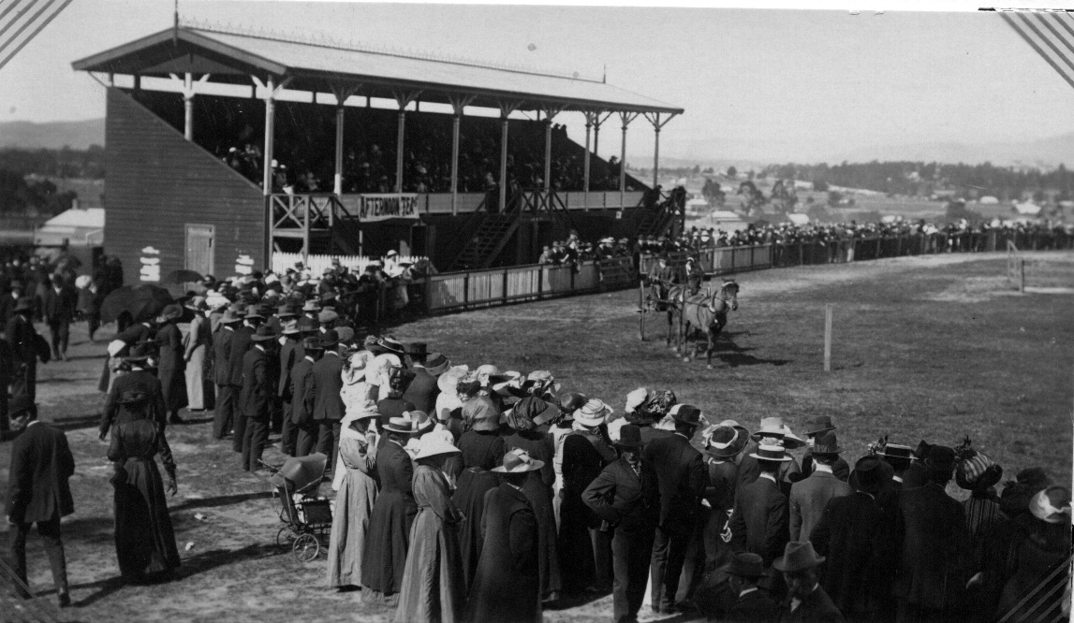

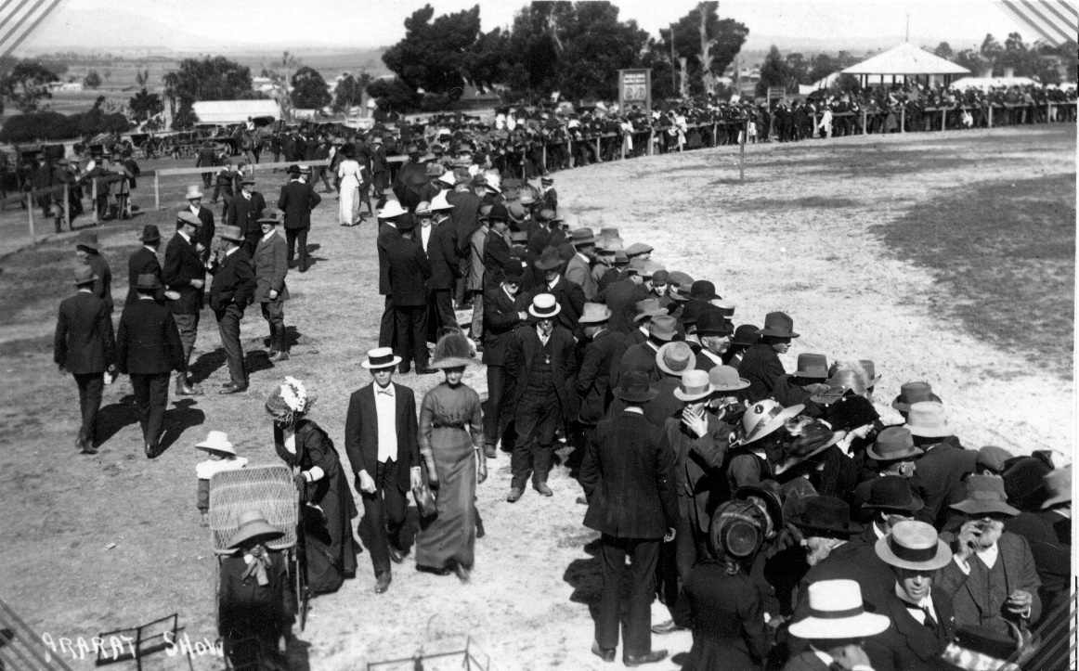

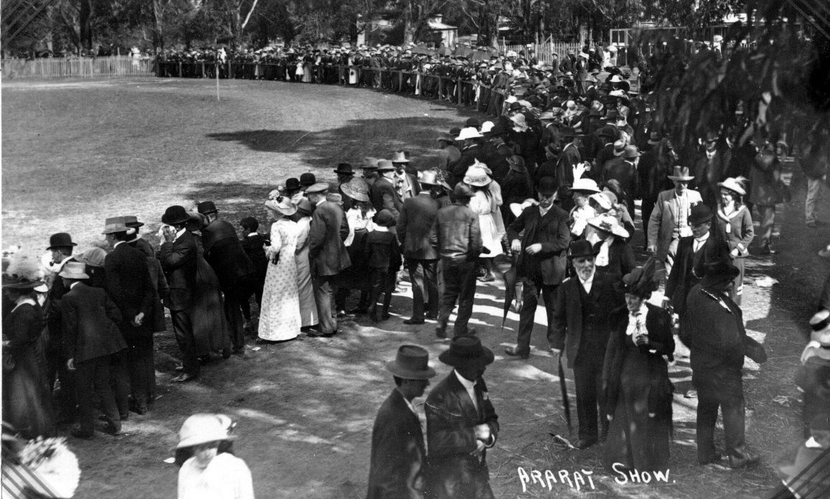

There were 70 working bees (Men, women and children) to create the new sports ground.

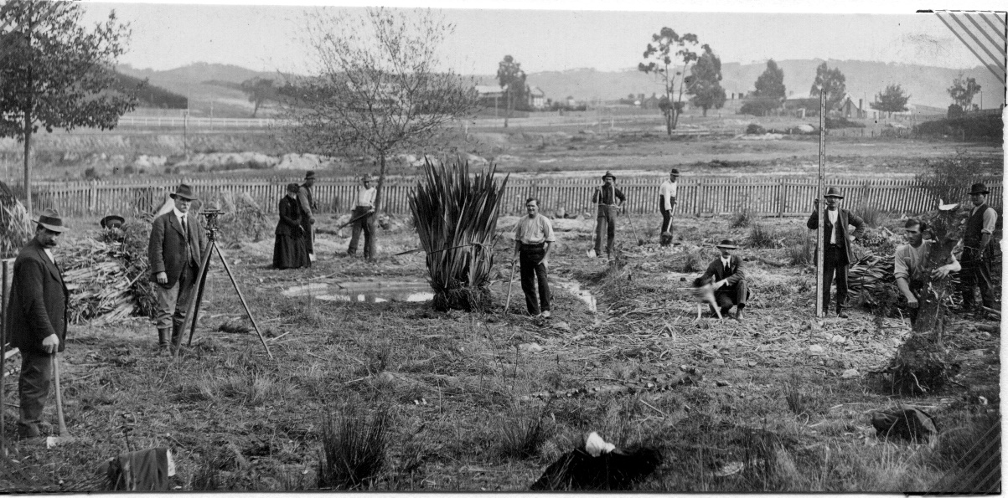

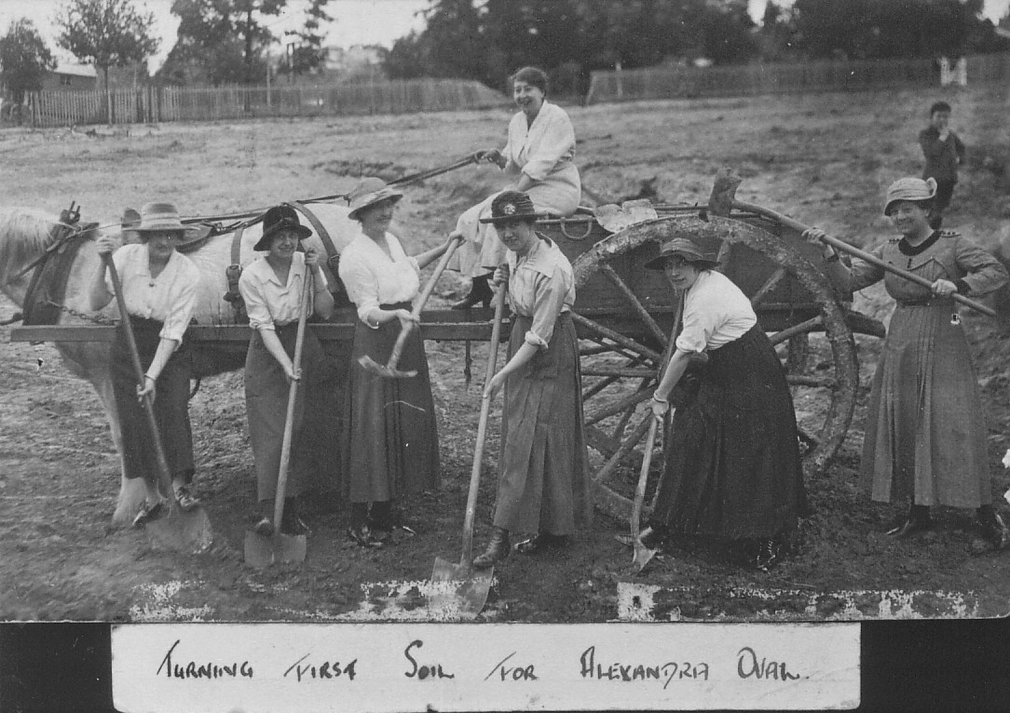

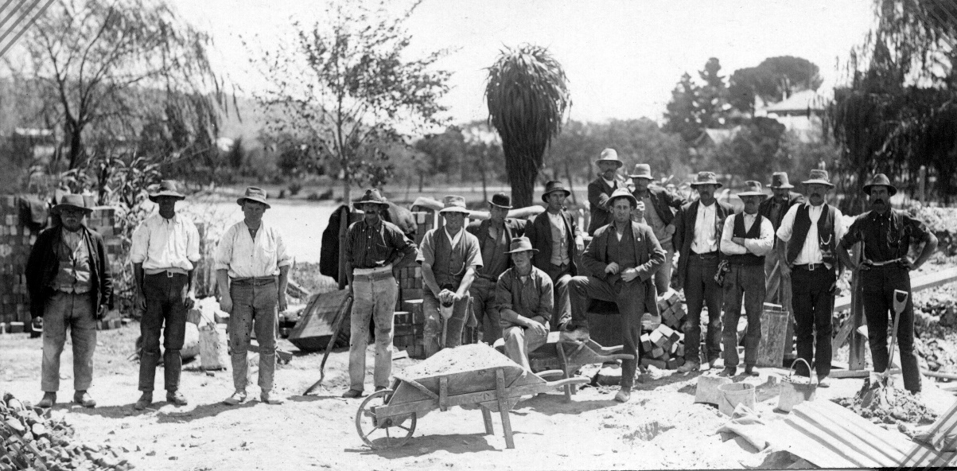

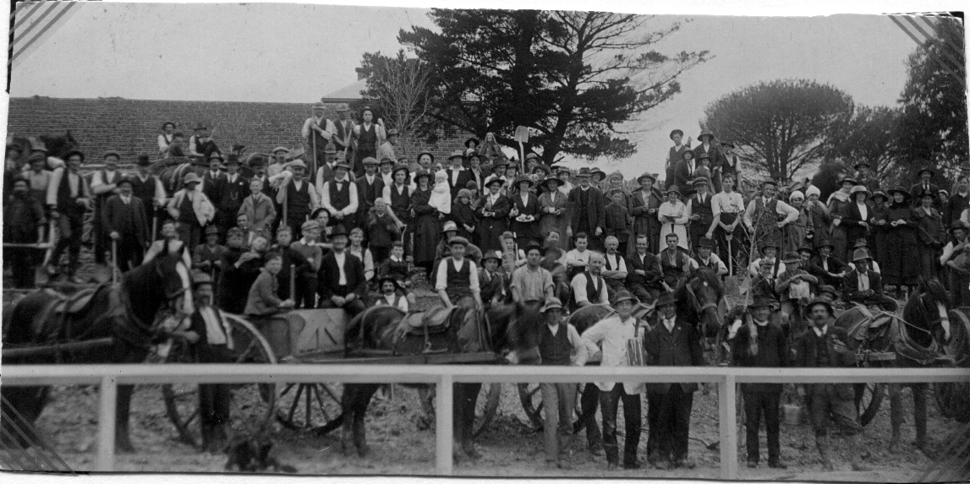

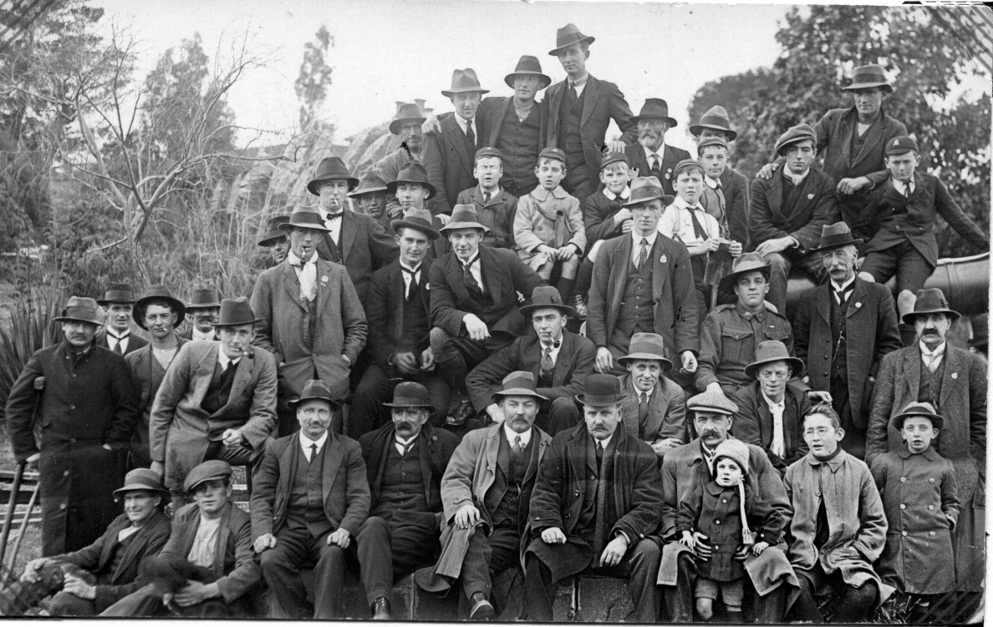

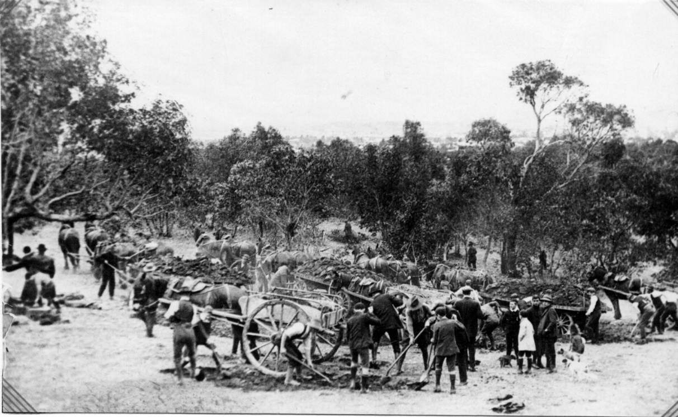

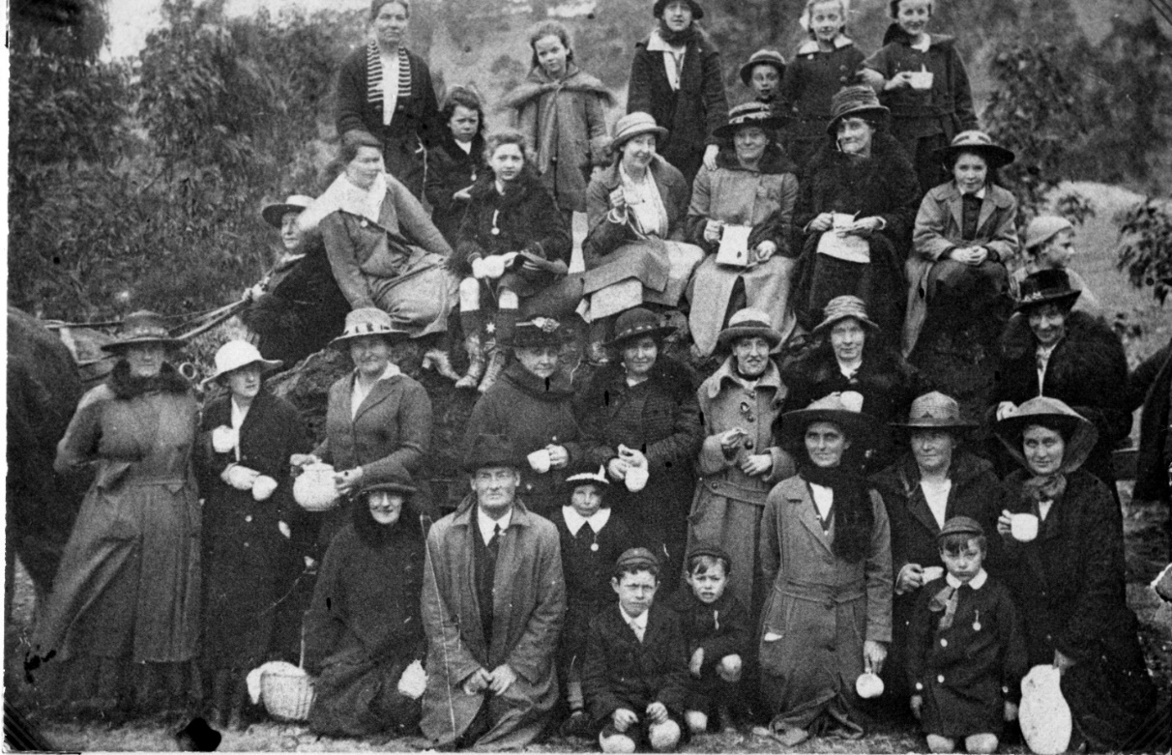

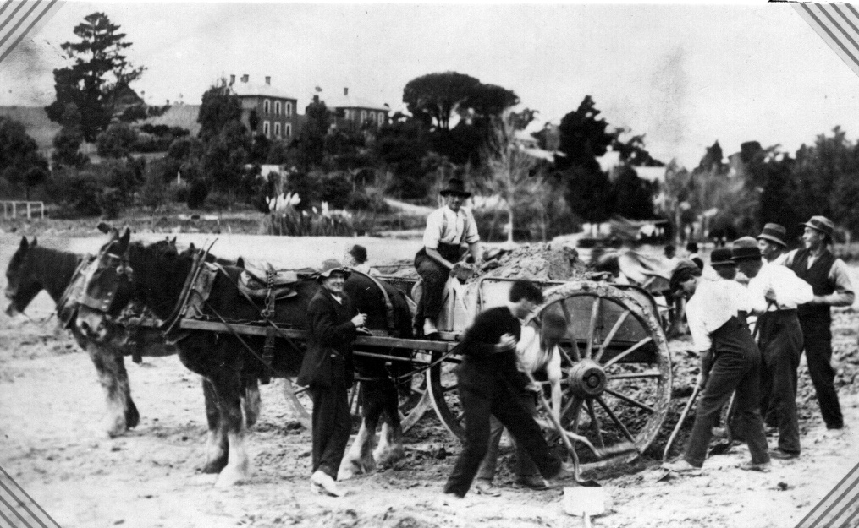

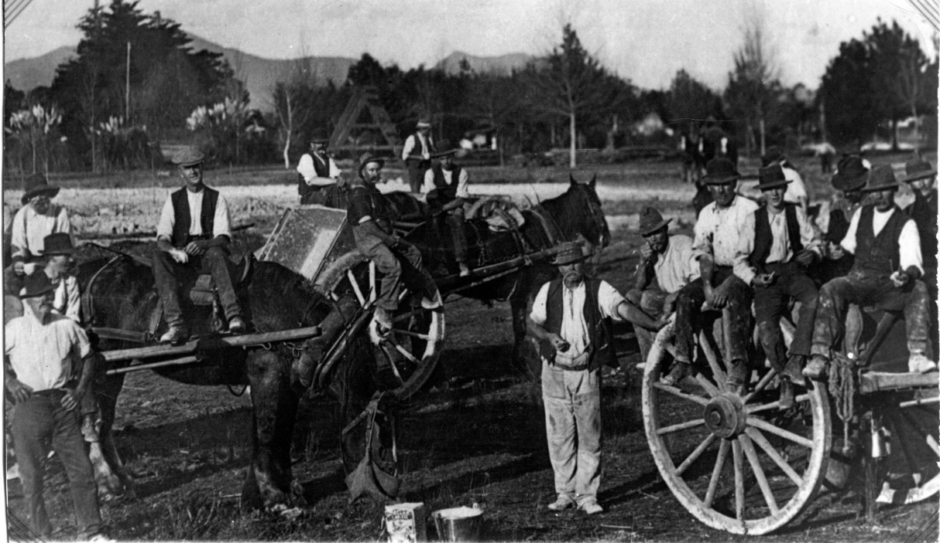

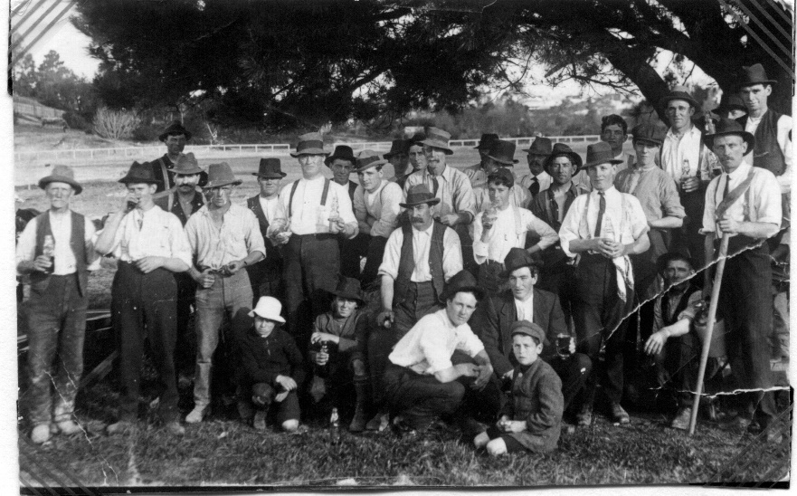

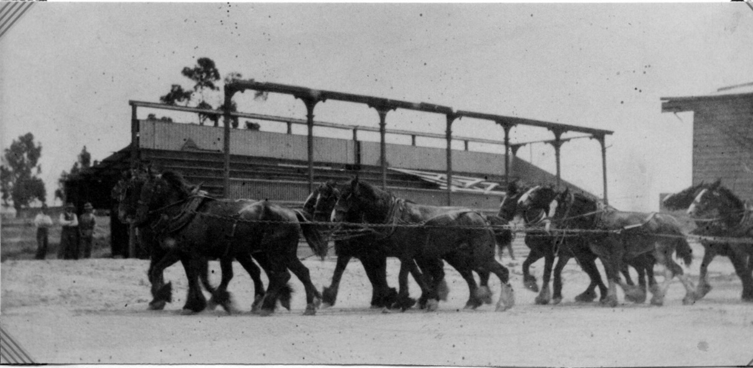

*Ararat Advertiser Saturday December 30 1920*

**ARARAT’S GALA DAY – OPENING ALEXANDRA SPORTS GROUND – ATHLETIC CLUB MEETING**

Boxing Day was a red letter day in the history of Ararat, when the New Sports Ground at Alexandra Park, on which so much laudable public effort has been expended, was officially opened by the State Premier, the Hon HSW Lawson, and dedicated to the use of the citizens. Indeed, the festive season was taken advantage of to the full, and a gala week was arranged which will live in the memory of residents as pleasingly celebrating the achievement of an undertaking of which the whole town may well be proud. Ararat has passed through quite a number of stages in connection with its open air recreation resort. Time was in the early gold field days when a huge population was centred about Commercial road, Commissioner’s Hill and Pump Town, when people assembled for outdoor sport in large numbers at the Green Hills, and some very successful and enjoyable fairs were held, but as the place settled down a situation not so remote was sought, and the old cricket ground was utilised as a recreation reserve. It possessed, however, not one redeeming feature. A low lying salt flat, remote from the centre of the town, even the residents in the neighbourhood turned their backs upon it, and a desolate flat had a desolate foreground, with here and there a somewhat dissolute looking back fence and outhouses. The bar sinister to the shield was provided when one of the main open sewers of the town was taken through the pleasure ground of the people, and children were invited to enjoy an outing on its banks, and at the same time run a by no means remote risk of infection by typhoid and other zymotic disease. A determined, indeed, it might be said, an obstinate effort was made to continue an impossible state of things, and many hundreds of pounds were recklessly spent in improvements, and under the compelling hands of Mr HA Linaker, then the curator of the public gardens, the place for a brief space blossomed as a rose. The gilding of the pill was nor regarded by many as a satisfactory remedy of the evil, however, and the movement initiated for the concentration of the sports of the town at a convenient spot steadily grow. Backed by a splendid public spirit – a spirit which no opposition could effectually kill, Mr Linaker, like Phidias of old, removed the debris from the old Botanical Gardens and revealed the beauties that lay hidden there. It was found that there lay concealed verdant lawns spreading from the marge of an islet studded miniature lake – that there were sweeping terraces and unsurpassed parterres of brilliant blooms – that within the proverbial stone throw of the principal business and residential thoroughfares there was room for spacious bowling greens, and tennis courts and croquet lawns, and a playing ground fitted with swings: giant strides and other means of pleasure and exercise for children. But end was not yet. The untiring band of enthusiastic workers merely used the splendid achievements of yesterday as the lever of Archimedes to ensure the culmination of their well-maintained effort by adding to Alexandra Park a public sports ground worthy of the town and in keeping with the existing club conveniences. The praise worthy efforts of all associated with the movement have resulted in a wild furze covered waste. Which included several long since deserted miners’ dams and the slum dam of an almost forgotten crushing plant, located below the gaol hill, into a spacious sports ground with an exceptionally fine arena, a wide trotting track of three laps to the mile, and all the conveniences necessary for the holding of sports meetings of a successful character. The new addition to the social side of the public life of the town was tried out on Boxing day, when a gathering of over 5000 people assembled, and all were loud in their praise of the convenience provided and charmed with the situation and the surroundings, declaring the place an ideal one. Compliments and congratulations were showered upon all concerned in the movement for the creation of the ground. The expectations of the committee were fully realised. Had the 5000 present been 25,000 there would have still been ample room for doubling the number, and every visitor would have enjoyed an uninterrupted view of the whole of the interests.

**The Official Reception**

The Premier, the Hon HSW Lawson, who had accepted the committee’s invitation to visit Ararat and officially open the new sports ground, arrived shortly after noon from Castlemaine, and was accorded a hearty welcome by the Mayor at the Town Hall, and the Parliamentary party included the State and Federal representatives of the district, Messrs RF Toutcher, MLA, the Hon. Drysdale Brown, MLC, and MR WG Gibson, MHR. The toast of the King having been loyally acknowledged, the Mayor (Cr EC McGibbony), in proposing the toast of Parliament and the Premier, expressed appreciation of the Premier’s action in coming to Ararat at, he was aware, considerable inconvenience. He extended to him the season’s greetings, and hoped that the visitors would spend a pleasant time in Ararat, on what was locally an auspicious occasion.

Dr Matthews, as President of the Athletic Club, joined the Mayor in welcoming the Premier. The club was exceedingly grateful that the Premier had consented to officially open their new grounds. He congratulated the Lawson Administration on having secured the reins of Government for another three years.

The Premier – Can you guarantee that? (laughter)

Dr Matthews – It was his hope, and on behalf of the club he wished the Premier a bright and prosperous new year, both in his official and private capacity. He desired to inform the Premier that the local public organisations had undertaken distinctive work at the grounds, wholly or in part as follows: - Borough employees – earthwork, Miners’ Association – eastern terraces, Mental Hospital Staff – gravelling of promenade and approaches, Fire Brigade – planting of shade trees and cypress ring fence, Footballers – arena fence, Trotting Club – trotting track, Athletic Club - running tracks, Cricketers – turf wicket for next season, Railway Union – asphalting of grandstand , approaches, dining room, etc. ANA – planting of ring of flowering gums around the arena. J Ward authorities – shrubbery on eastern hill and planting of Virginia creeper to cover J Ward wall. Langi Logan quarrymen – screenings for asphalting. Road concreters of both Borough and Shire of Ararat – earthworks, The Citizens Band was the first organisation to take debentures. The bandsmen have organised working bees and massed workers in the town and led them to the grounds. Working bees have been arranged by the Bankers, the Bowling Club, the High School Council, the Primary and Secondary teachers, the Mayor and Councillors. The sources of revenue were – Grant by Federal Government £750, debenture issue £1250, donations in cash and revenue from entertainments £950, voluntary labor and donated material £1650; total £4600.

As analysis of voluntary labor and donated material showed the following: earthwork £700, surveyors’ fees £200, cartage £200, gravelling £150, asphalting and screenings £80, painting £80, carpentering £80, loam £120, plumbing £20, blacksmithing £20, total £1650. There have been 70 working bees and the ladies have provided refreshments for the workers on these occasions. At one working bee there were 270 workers present. The ladies have also raised the most of the money derived from entertainments, one bazaar returned £352 net, while an afternoon fete brought in £162 net. There have been several smaller efforts made by the ladies of Ararat. The curator of the borough, Mr Lloyd, has given an immense amount of his own time in over-seeing the work. He was very proud to be the President of the club, with which he had been connected for some years, in the year which saw the opening of the new ground, and the Premier would find it one of the finest in Victoria – not regarding the appointments, which could not compare with the cities, but for its situation, possible landscape effects, arena, gardens and other details. There had been a fine committee of men at the head of the movement, who for years had given voluntary effort, and up to the present time about £4600 (though not in actual cash) had been expended in voluntary labor, materials, etc. There were 70 working bees and at one 270 were present and worked with a will. When all did so, he did not like to single out anyone, but Mr Lloyd stood out prominently. He resuscitated the movement from the setback which followed the expenditure of the money granted by the Government in connection with the employment of returned soldiers, and had raised a large sum. The ladies, too, should be mentioned, for they had provided refreshments at all the working bees.

An answer to Mr Toutcher, Dr Matthews said that about £4000 had also been spent in voluntary effort in making Alexandra Park.

Mr TG Grano briefly supported Dr Matthews and Mr Oke, the secretary of the movement, was called upon, and gave some interesting details of the work done. It was a wonderful manifestation of the public spirit of Ararat. It was to him quite an inspiration, and socially, industrially and politically the world would be better were this spirit to obtain a wider expression. As one interested in secondary education, he hoped Ararat would now be the centre for the champion school contests of the Grampians and Northern Association.

The Premier, who was cordially received, thanked the Mayor and councillors and members of the Sports Ground Committee for their kindly welcome. They seemed to think that he had come to Ararat at some inconvenience, but he might say that so far as the severance of home life at this season of the year, he had brought some of his kids with him in the car; but he was the Parliamentary representative of Castlemaine, and he could not bring with him to Ararat a function he had to attend there that afternoon. He had to regard the interests of his constituency, and return there for the function. He had with pleasure accepted the invitation of Mr Toutcher to be present. He had been politically associated with their member for 21 years, and they had been personal friends, and he was pleased to accept the invitation and pleased to be present in Ararat on such an occasion. Indeed, he was delighted to be associated with such a movement. He asked them to accept his presence as the representative of the Government as an assurance of their deep interest in the inland countries, and he realised that the movement culminating that day was a practical agency for decentralisation. Every agency they employed for enriching the life in the country had their fullest appreciation, because it was the means of grappling with an evil of huge proportion in Victoria – the concentration of so disproportionate a number of the people of the State in the one city. What was wanted was the encouragement of healthy, wholesome recreation of honest, manly sport. It was necessary by physical training to add to the physique of the people and to find an outlet for our energy, and the development of a sound mentality. To do this, certain things were necessary. The necessity of higher education was realised by all, and the Government was doing its best by the establishment of secondary schools, but they must have Mechanics’ Institutes, Debating and Literary societies, etc., so as to get a richer life in the country. What drags any parents of children to Melbourne in the knowledge that there they can readily secure facilities in this direction, but what the Government aimed it is to get a richer and better life in the country by affording all possible opportunities to residents to service the development of the mental, artistic and literary talents of their children. It was also essential that life should be made cheerful, and recreation must be provided for with healthy athletic exercise. By this means the race educated in those social, economic and industrial problems which had to be faced. No-one could doubt the advantages of higher training. They had only to think of the abiding pleasures of literature to realise this. He had always been fighting for increased educational opportunities, and he knew the advantages of physical training. He was pleased to have been furnished with so much information of what had been done by the public spirited people of Ararat, and he hoped the earnest and enthusiastic citizens would thrive and prosper (applause)

Mr WG Gibson, MHR, in acknowledging the toast, congratulated the people of Ararat on the fine healthy spirit of citizenship displayed by the expenditure of £9000 in making public gardens and recreation reserves. They had done a work which could not be too highly recommended.

The Hon. Drysdale Brown and Mr Toutcher also spoke in similar terms, the latter stating that when asking the Premier to be present he said that he felt proud that Ararat had shown such a splendid civic spirit. It was an example to the whole state.

Mr Toutcher proposed the health of the Mayor, which he briefly replied to and the gathering adjourned to the sports ground.

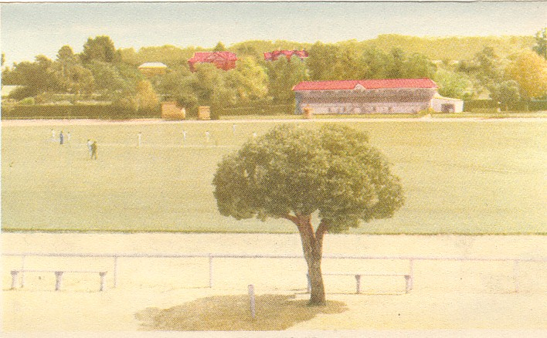

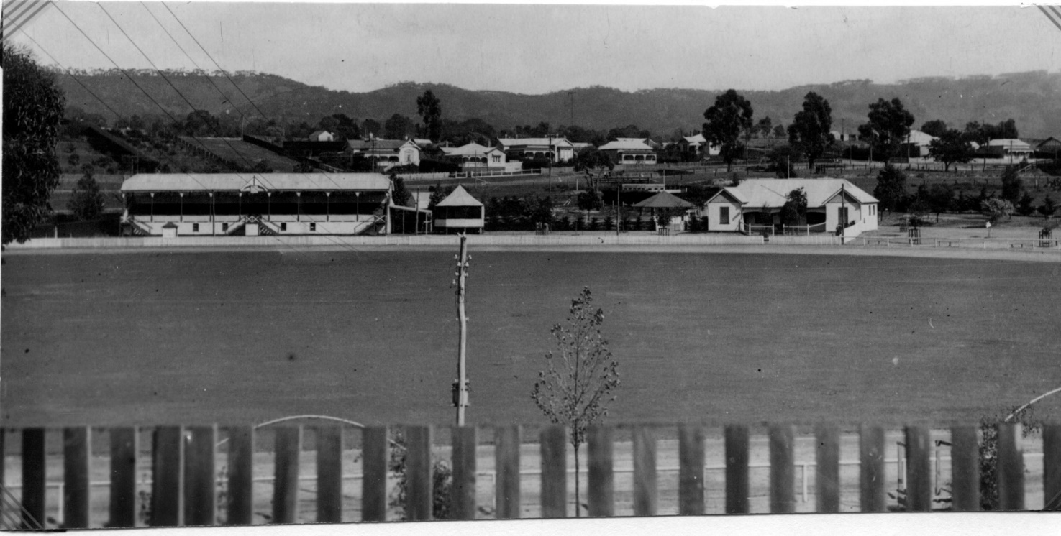

*Ararat Advertiser Thursday November 20 1958*

**CITY COUNCIL TO HELP PROVIDE NEW DRESSING ROOMS AT OVAL**

The City Council will ask the Football Club and Trotting Club to prepare plans and specifications and call tenders for construction of new dressing rooms at Alexandra Oval.

The action was taken by councillors on Monday night in preference to raising a loan of £2000.

A deputation comprising the president, Mr Len Ford, and secretary of the football club, Mr RJ Falla, and Mr K Clover, a member of the Trotting Club committee, waited on the council.

Spokesman for the group, Mr Falla, the proposal to build new clubrooms at the oval had been shelved in the past because of lack of money. An amount of £2000 was now available and there seemed no reason why work should be delayed any longer.

The Football and Trotting clubs were the main users of the ground and it was unlikely that any objections to the project would be raised by other sporting bodies.

**Council Help**

Rough plans had been proposed by a builder whose firm estimate was £4500.

The council had indicated to a previous deputation that it was possible to obtain a Government grant of £800, Mr Falla said. When the club’s contribution of £2000 was added it left only about £1700 to complete the building.

The new building would enhance the oval and the old building, which was in a good state of repair, could be removed and re-erected at centenary Park where facilities were urgently required by district sportsmen.

The Football Club would like the new rooms to be ready for the 1959 football season, he added.

**Concrete Price**

The proposition was a worth-while one from a council point of view, Cr Marx said, when he moved, seconded by Cr James, that council raise a loan of £2000 to meet the cost of the new building and removal and re-erection of the old dressing rooms.

The council should assist the clubs as much as possible, Cr de Crespigny said. However, no concrete price had been submitted, only a rough estimate.

“Before we make arrangements for a loan we should know exactly what we are up for.”

He moved an amendment seconded by Cr Murphy that the council do all it could to assist the Football club in providing new dressing rooms but before any further move the club first obtain plans and specifications and tenders for the job.

The amendment was carried.

*Ararat Advertiser Thursday March 12 1959*

**TENDERS FOR NEW OVAL CLUB ROOMS CLOSE LATER IN MONTH**

The City Council may guarantee to have the dressing rooms at Alexandra Oval removed and ready for an immediate start on the construction of modern club rooms for the Ararat Football Club.

Tenders are now called, is to be completed with 4 and a half months of work starting, and the club asked that old buildings be removed.

Previously it had been taken for granted that the old rooms would be removed to Centenary Park, the acting engineer, Mr J Carter said.

The council had obtained a Government grant for erection of sheds at the park.

**Inconvenience**

The Football Club was willing to accept inconvenience in order to have the new rooms erected as quickly as possible, Cr Blachford said.

“If the construction was deferred until after the playing season the removal of the rooms would interfere with the trotting and cricket events”, he said.

He moved, seconded by Cr Murphy, that information on the removal of the old dressing rooms be provided by the engineer for the next meeting on March 23, three days before tenders close on March 26.

The council would be in a position to advise the club of the position before tenders were considered Cr Blachford added. Plans and specifications for the building would be presented to the council for final approval after tenders closed, Mr Carter said.

*Ararat Advertiser – Saturday April 4 1959*

**VARIATION OF** £**1900 IN CLUBROOM TENDERS.**

Four tenders, ranging in price from £6671 to £44738, have been received by the Ararat Football Club for a modern brick veneer club rooms at Alexandra Oval.

The tenders which were opened at a special meeting of the club on Wednesday night, will be forwarded to the City Council in time for Monday night’s council meeting.

A number of club officials will, it is believed, sit in the gallery to hear council debate on new rooms and the report of the city engineer on cost of removing existing dressing rooms to Centenary Park.

Club secretary, Mr RJ Falla said yesterday that no recommendation would be made as to which tender the club thought should be accepted. That was a council matter.

“We have done the job the council requested us to do by having plans and specifications prepared and calling tenders” he said.

The football club, with assistance from Ararat, Stawell and District Trotting Club, would have £2000 to put toward the project, Mr Falla said. The club would meet cost of plans and calling tenders.

**Low Estimate**

Details of tenders were – Mr DL Coxall, of Bunningyong, £6671: Mr RJ Stewart of Ararat £5399/16: Mr JJ Blackie of Ararat £5435, and Mr SL Phillips of Ararat £4738/2/6.

Preliminary estimates for building set the price at about 4500 pounds, Mr Falla said. The lowest tender price was 238 pounds to excess of this.

Last year the club approached council to see if it would help in erection of building, he said.

A Government grant of £800 would increase money available for the job to £3800.

On these figures the sum of 1598 pounds had still to be raised and it was hoped that the council would raise a loan to allow work on the clubrooms to proceed immediately.

**Divided Room**

The clubroom is planned with one 60 feet by 30 feet room fitted with a folding dividing wall to make two dressing rooms. Coffee, first aid and property rooms and a kitchenette are also included.

A few alterations are necessary to toilet block of existing building to suit new clubroom.

Building line of new rooms would some to edge of verandah of present dressing rooms. This would allow much more space in dressing rooms which during the football season were always overcrowded.

The club intended that all money raised in future should be devoted to improving interior of new building and providing furnishings, Mr Falla said.

A wooden floor was to be erected over the concrete slab floor of existing rooms. To protect the surface, it was possible that the club would use heavy coir matting in football season to prevent damage by stops.

*Ararat Advertiser Saturday April 4 1959*

**CLUBROOMS GO TO THEIR NEW HOME.**

Ararat Football Club’s training rooms on the move Thursday. The building is to be erected at Centenary Park where it is expected to be a big asset to teams competing in the Ararat Association. The job was carried out by Messrs E Nunn and Son, who started the job on Thursday morning and had the 60 by 30 front building on the move by Friday morning. A great deal of trouble was experienced in manoeuvring the room across the trotting track and up the “J” Ward hill to Girdlestone street. Amazingly little damage was done to the ground surrounds during the big operation.

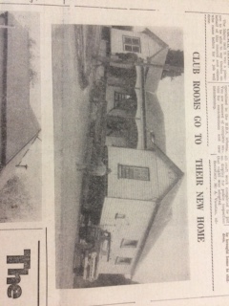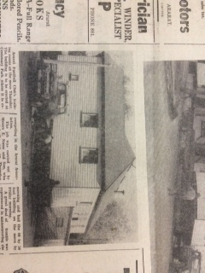

*Ararat Advertiser May 9 1959*

**BANK FINANCES OVAL PAVILLION**

Mr HP Peters, manager of the Ararat branch of the State Savings Bank of Victoria, has announced that the bank had granted a loan of £2000 to the City of Ararat.

The loan will be repayable over a period of ten years with interest at the rate of 5 and a half per cent per annum and will be used to finance the erection of a new brick dressing pavilion at the Alexandra Oval.

Mr Peters went on to say that the new loan would be additional to those of £2350 and £2500 which were granted in November and December of last year respectively. These loans were associated with council projects relating to internal administration and electricity extensions.

*Ararat Advertiser Tuesday December 1 1959*

**FISCALINI PAVILLION WILL BE THE BEST IN THE WIMMERA - COMPLETION**

Claims by the councillors and football officials that the James Fiscalini pavilion at Alexandra Oval is the best in the Wimmera are not without foundation.

The spacious brick veneer building expected to be completed by early December, has every facility necessary, not only for football but for every sporting organisation using the oval.

It is a fitting building to grace the fine setting of Alexandra Oval, and unlike other pavilions has an off season use.

Built by SL Phillips and Sons for £4800, it stands as a monument to James Fiscalini whose work as a curator of the grounds was always readily extended in the interests of all who used them, and who still lives to proudly see the pavilion in use.

Towards the cost the Football Club contributed £2000, of which over £400 was raised by special effort in conjunction with the Trotting Club, and by the sterling work of the ladies’ committee.

Now these bodies are working for further additions to add value to the pavilion.

The Football Club is to provide covering for the main room, to preserve the floor at a cost of approximately 150 pounds, the Trotting Club will construct a set of wide concrete steps across the front of the pavilion, and the Highland Sports Society will provide rails and pegs around the rooms, a tender for which has been accepted for £31.

**The Building**

Two double doors centre the front of the eastern side of the building, opening off a wide concrete verandah running the full length and set off with bricked-in flower box.

The main hall, approximately 60 by 30 feet, will be divided by folding doors, providing for two dressing rooms.

Provision is made for separate showers and conveniences at the western end and off the main room is a wide tiled bath capable of holding four persons.

Four large windows, two on the wall, give ample natural light and a stone faced fireplace is set in the eastern wall between the first window and double doors.

A kitchen, administrative office and property office with ceiling to floor storage, are included in the building. The kitchen is fitted with ample cupboard space and hot and cold water, and the first aid room has a separate outside door for easy access to ambulance.

Main hall and offices are lined with Masonite from the floor to four feet, then plaster to the ceiling.

Eventually the pavilion will be set off by the planting of native shrubs and trees.

The whole structure is due to combined efforts of three clubs and the football ladies’ committee and will stand to the credit of Ararat generally for years to come.

*Ararat Advertiser Thursday January 14 1960*

**AFC CANNOT CHARGE AT PAVILLION OPENING**

Permission has been granted the Football Club to officially open the “James Fiscalini” pavilion in Alexandra Sports Ground on Friday, January 29, but no admission charges can be made until the building is registered with the Health Department.

The club planned an official opening ceremony on the terrace fronting the pavilion, followed by a social and dance for which an admission charge was to be made.

Money received was to be put towards the cost of furnishings for the room.

After Crs Ford and Johnstone had moved, at Monday’s meeting of the City Council, that the application be granted, Cr James asked whether the building was suitable as a place of entertainment.

Health inspector, Mr US O’Toole, explained that registration must be obtained if it was to be used for pubic entertainment. Upon receipt of application for registration it would be inspected by an officer of the department. Cr Ford then incorporated his motion “that permission granted provided no charge be made”.

**To Remove Tree**

The football club also suggested the removal of the gum tree in front of the pavilion and replacing it with a planned display of shrubs.

Cr Murphy moved that the tree be removed and permission given to plant shrubs under the advice and supervision of the curator. This was seconded by Cr Ford and carried.

*Ararat Advertiser Tuesday February 2 1960*

**A MONUMENT TO A LIFETIME OF WORK**

“I trust that those who use this building will regard it not so much as a dressing room but as a monument to a lifetime of work by a mighty man – James Fiscalini.

That was said by the president of the Ararat Football Club, Mr Len Ford on Friday night before handing the keys of the James Fiscalini pavilion to the Mayor of Ararat, Cr RA Blachford.

Both the Mayor and the club president expressed a sense of indebtedness to the ladies’ committee of the Ararat Football Club, the Ararat-Stawell and Districts Trotting Club and Highland Society for contributions which helped to make the pavilion possible.

Mr Ford said if sporting clubs pulled together like this more often better results all round would be achieved.

He thanked the architects who designed the building, and the builders, Messrs SL Phillips and staff, who did an excellent job.

“I have much pleasure in accepting the key from the president of the Ararat Football Club” Cr Blachford said.

This represents a really good combined effort by sporting bodies, with the greatest credit to the Football Club ladies’ committee whose efforts over the years raised a considerable sum of money, enabling the club to go ahead with the project.

The Football Club knocked on the door of the Government and they spared a little finance, the City Council added something and the Trotting Club and Highland Society joined in.

This great effort, said the Mayor, resulted in a fine building which was “a monument erected to a great man, an untiring and unselfish man”.

**Best in Australia**

Cr Blachford referred to three letters he had received from various parts of the State with congratulations on the wonderful building which had been made available for athletes at the Boxing Day sports meeting.

He believed the building was equal to any sports pavilion of its size in Australia. It was in keeping with the sports ground, for which much credit goes to Mr Fiscalini.

“There is not a better sports ground in Australia than what we have here in Ararat” said Cr Blachford.

“Guard this pavilion, look after it with the same care that Jim Fiscalini did the sports ground and gardens – with fatherly care.” the Mayor added.

“Each of you is a custodian, so let nothing be done to destroy or damage it in any way,” he advised.

The ceremony was conducted on the front steps of the pavilion, and at its conclusion the Mayor handed the key to Miss L Bonner, president of the ladies’ committee, who opened the doors of the pavilion.

Present at the ceremony were the Mayoress (Mrs Blachford), the Town Clerk (Mr JI Grenfell), city engineer (Mr NW Baldy), Crs O Marx, L Ford and R de Clerq, officials of the Football Club and ladies’ committee, Trotting Club and Highland Sports Society, representatives and players and supporters of the Football Club, who later enjoyed a social and dance inside the spacious building.

**Go karting around the trotting track at Alexandra oval in the 1960s**

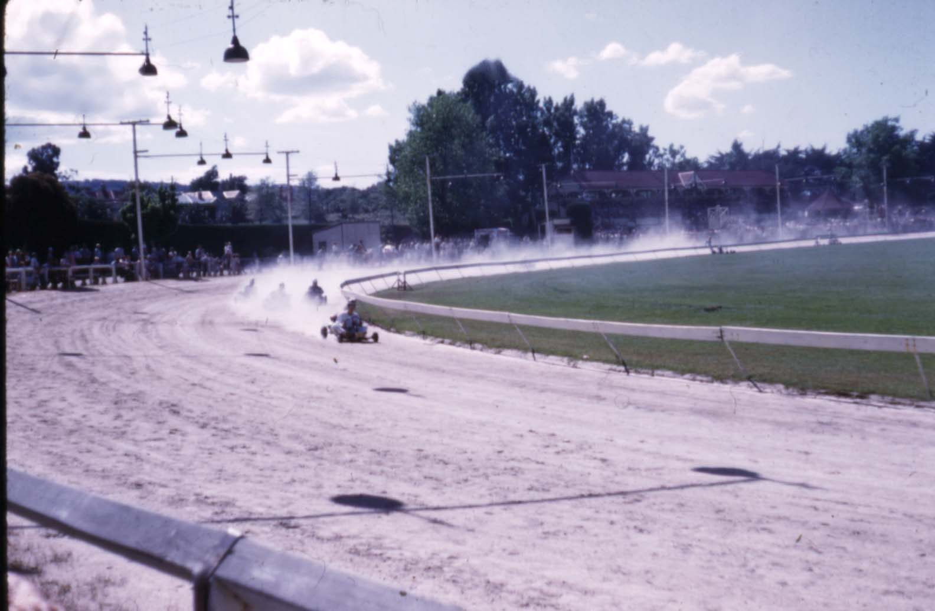

Ararat *Advertiser December 1 1960*

**NO PAVILLION KEY FOR ARARAT FOOTBALL CLUB**

At its meeting on Monday night, Ararat City Council refused a request of the Ararat Football Club to have a key of James Fiscalini issued to a responsible person.

Making the request, the club gave as its reasons that (a) as football club activities continue throughout the summer, regular committee meetings are necessary; (b) on many occasions and most weekends, old players and supporters returning to Ararat are eager to see the pavilion and photos and pennants are kept therein, and (c) it is felt, having contributed liberally to the cost of erecting the pavilion, the request was reasonable.

Moving that the application be granted, Cr TL Ford said it was very frustrating to have to get the key every time the club officials wished to use the pavilion.

“The club have proved good ambassadors for the city and their members were noted for their good sportsmanship and exemplary conduct.” he said.

Seconding the motion, Cr O Marx said he felt the club was a trustworthy body and part owners of the building.

“They are, and everyone else is, proud of the building and by granting a key harm could not come of it.” he added.

Cr Blizzard opposed the motion on the grounds that another club had been refused a similar request at the last meeting of council.

“I agree that some members are responsible and desirable but it is not true in every case.” he said.

The Mayor said there acts of vandalism there at times and it was no handicap to let the Town Hall that a key was wanted.

“I think we are guarding the property well for these people themselves” the Mayor said.

Cr de Clerq – “The Ararat Football Club does use the building a good deal and it may be difficult at times to get a key, but on the other hand there are other bodies that use it. If we do it for one, we must do it for all.”

Cr Johnstone – “I believe the club requires the key for convenience more than anything and I am sure that they will look after the building to the best of their ability. I believe their request is a very reasonable one.”

Crs James and Murphy opposed the motion on the grounds that if one organisation was granted a key all are entitled to one.

Closing the debate Cr Ford said acts of vandalism were not so likely to occur if someone was moving about more often.

“I would not like to be on the receiving end if football club members got on to vandals at the pavilion.” Cr Ford said.

The motion was lost.

*Ararat Advertiser Saturday December 1 1962*

Ararat Football Club could possibly be denied the use of its own club rooms for committee meetings, the James Fiscalini pavilion, towards the construction of which it contributed £2000.

A letter from Town Clerk, Mr Grenfell, said future applications for use of the pavilion must be forwarded in time to be presented at council meetings, otherwise your request will be refused.

Bob Falla jumped to his feet and declared “we are being treated like a lot of – I don’t like to use the adjective – school children. We have a £2000 equity in that building and we should endeavour to get the building as and when we like. I am fed up to the neck about the whole matter.

*Ararat Advertiser Thursday January 8 1968*

A request by the Ararat Football Club for the abolition of the rental fee ($1) for the use of the Fiscalini pavilion for committee meetings was granted by the City Council on Monday night.

*Australia’s National Local Government Newspaper Online.*

**A BRIGHTER FUTURE FOR OVAL**

A state of the art lighting upgrade at Ararat’s Alexandra Oval means that State, or even national level sporting events can now be held in the municipality.

Last year Council installed four, 25 metre lighting towers with 24 2000 watt lamps, raising the facility’s lighting to 100 lux, the Australian standard for club football.

The new lighting was funded using $100,000 of the State Government’s $300,000 Local Works Infrastructure Program funding for drought affected communities.

Council is now in the process of delivering on stage two of the project, by installing two more lighting towers, at a cost of $80,000.

Council will split the cost with Ararat Community Enterprise, an independent organisation that has chosen the Alexandra Oval Master Plan as its major community project. Ararat Community Enterprise operates as a Telco retailer, pouring profits back into community projects.

Mayor Councillor Gwenda Allgood said the lighting upgrade was a major achievement for all involved, including the Alexandra Oval Committee of Management.

“This project means that Alexandra Oval will have the highest level of lighting of any sporting ground in the Wimmera Grampians region,” she said.

“Not only will our local sporting clubs enjoy this major facility upgrade, we’ll be increasing our chances of hosting major sporting events in Ararat, which is fantastic on many levels.”

*Ararat Advertiser March 1 2013*

**ALL SYSTEMS GO FOR ALEXANDRA OVAL**

Ararat's sporting community is celebrating following yesterday's announcement of a $1.15 million funding boost to develop the new multi-purpose pavilion at the Alexandra Oval Community and Recreation Centre.

In Ararat yesterday, Minister for Sport and Recreation Hugh Delahunty said the funding was part of a Victorian Coalition Government facility funding package for the popular sporting precinct.

"A key objective of the Coalition Government is to build healthy and active communities," Mr Delahunty said.

"To achieve this goal, we need quality community facilities that encourage local people to play the sports they love for many years to come."

"I'm proud to say the Coalition Government's funding package is made up of $650,000 from the Community Facility Funding Program - Major Facilities category and a further $500,000 from the $1 billion Regional Growth Funds, Putting Locals First Program," Mr Delahunty said.

Mr Delahunty said the project would replace the existing outdated change-rooms with bigger and better change-room facilities catering for football, cricket, netball, umpires and match-day requirements.

"It will also involve construction of a multi-purpose community space, meeting room, function space, commercial kitchen, canteen, first aid room and public amenities," Mr Delahunty said.

"The new multi-purpose pavilion will provide much improved sports facilities for local cricket, football, netball, tennis and an accessible community space that can be hired by the broader Ararat community.

"Our investment in this project is part of our plan to build more sustainable local venues that make a difference to local people," Mr Delahunty said.

"I congratulate the Ararat Rural City Council for developing the project and their investment of $2 million, as well as the Ararat Community Enterprise for their contribution of $100,000 and the Alexandra Oval Reserve Committee of Management for their contribution of $70,000.

"This investment is just one of the ways we are delivering on the Coalition Government's strategy to grow the economy, build infrastructure and contribute to the health and wellbeing of the State.

Deputy Premier and Minister for Regional and Rural Development Peter Ryan said Putting Locals First was devised to support improvement projects that reflected local priorities.

"By helping local communities take action on their own behalf we can help them improve local infrastructure and contribute to a better quality of life for regional Victoria," Mr Ryan said.

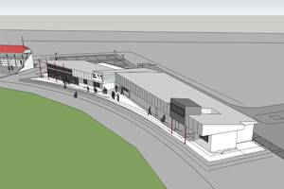

*Ararat Advertiser November 17 2014*

**COMMUNITY AND RECREATION CENTRE AT ALEXANDRA OVAL HAILED 'ONE OF THE BEST OF ITS KIND' AT GRAND OPENING**

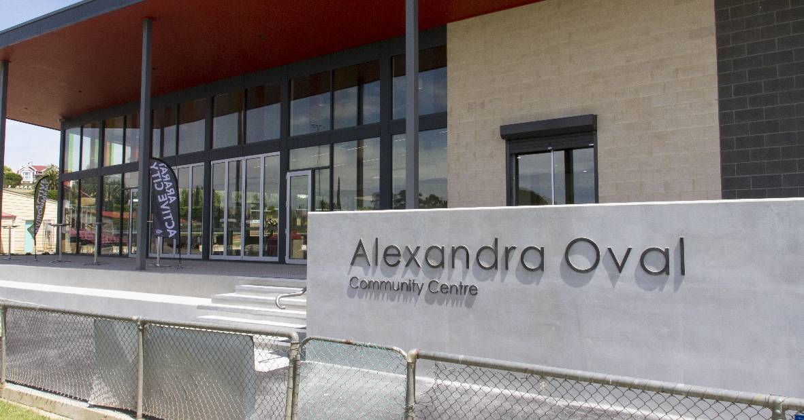

 Minister for Sport and Recreation Damian Drum has declared the Community and Recreation Centre at Alexandra Oval to be one of the best sporting facilities of its kind in regional Victoria. Picture: PETER PICKERING

ARARAT and the surrounding districts are set to benefit for decades to come following the official opening of the new $3.8 million Community and Recreation Centre at Alexandra Oval.

Minister for Sport and Recreation Damian Drum has declared the state of the art facility to be one of the best sporting facilities of its kind in regional Victoria and said the redevelopment will have a profoundly positive impact on Ararat including attracting big events to the region.

"This is right up there with the very best," he said.

"It has been built to a standard higher than just a community facility, so we will have the opportunity to host AFL practice matches and the like, this will be a regional centre for all sports.

"It is an amazingly well built facility that seems to have ticked all the boxes and will give all of the participating clubs the facilities they need."

Minister Drum was joined by Victorian Deputy Premier Peter Ryan and Senator for Victoria and Parliamentary Secretary to the Minister for Education, Scott Ryan, along with more than 100 members of the Ararat community at the grand opening on Thursday.

Ararat Football-Club stalwart Harold Bright, 96, had the special honour of unveiling the commemorative plaque to mark the official opening of the multi-use facility.

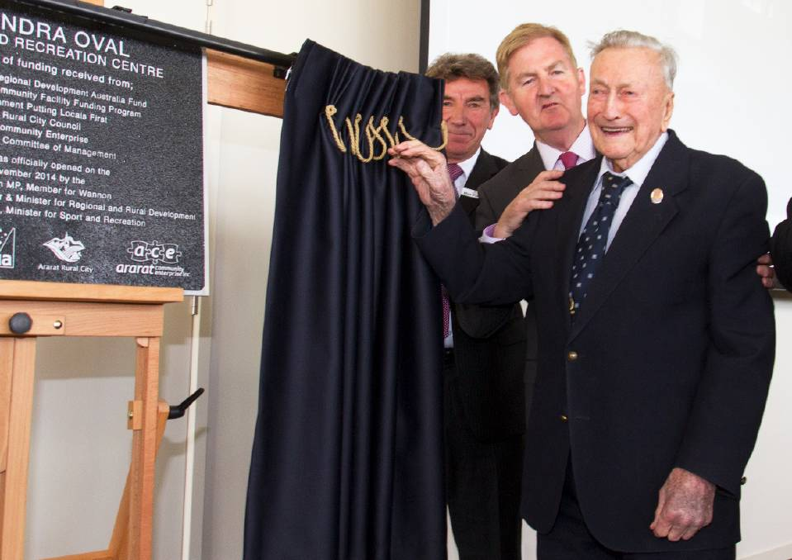

 Ararat Football Club stalwart Harold Bright had the honour of unveiling the plaque and is pictured with Ararat Community Enterprise chair Max Perovich and Deputy Premier Peter Ryan.

Among the crowd was Gayle Dadswell, who was the chairperson of the Alexandra Oval Committee of Management - the group that rallied for more than 10 years to get funding for the project.

Ms Dadswell said standing in the end result was an overwhelming experience and extremely satisfying to see the culmination of team work and determination.

"I just can't stop smiling," she said.

"I actually do feel really emotional, I don't think I ever thought this day would come and I am just so proud of a whole lot of people.

"Really it has been a team effort, from all the community members, Council, State and Federal government, everyone was pointing in the right direction and we have ended up with something that is bigger and better than any of us thought we would ever get.

"I think everyone involved has done a terrific job - I just can't wait to see community groups using it now and getting the most out of it."

Ms Dadswell said she would like to see the facility become a meeting point for the community to host an array of functions, which in turn will hopefully generate enough money to fund the second stage of the project, relocating netball courts to the rear of the reserve.

Councillor Gwenda Allgood, who has also been a strong advocator for the redevelopment for more than a decade, said this was one of the most significant projects Ararat has seen and one she is very proud to have been a part of.

"I have been on Council for 30 years and I think 10 of those have been spent fighting for this - I just think it is absolutely magnificent," she said.

"To actually see so many people here showing so much support for it, that really proves that Council has spent its money in the right areas.

"Already they are talking about what football finals can be held here and we have people from Melbourne looking at it and actually saying what a great facility it is, so what more can you ask for?

"Sport and recreation has always been one of my great passions and now how great is this for those young ones who are going to come through the system."

Construction of the Alexandra Oval Community and Recreation Centre was made possible with funding from the Australian Government ($500,000 from the Regional Development Australia Fund), two grants from the Victorian Government ($650,000 from the Community Facility Funding Program and $500,000 from the Putting Locals First Fund), Ararat Community Enterprise ($100,000) and Ararat Rural City Council ($2 million, including the Alexandra Oval Reserve Committee of Management's $70,000).

The investment has delivered new football and netball change-rooms and showers for home and away teams, umpire change rooms, a separate trainers' room, coaches' room, first-aid room, offices and a timekeeper's box with sweeping views of Alexandra Oval.

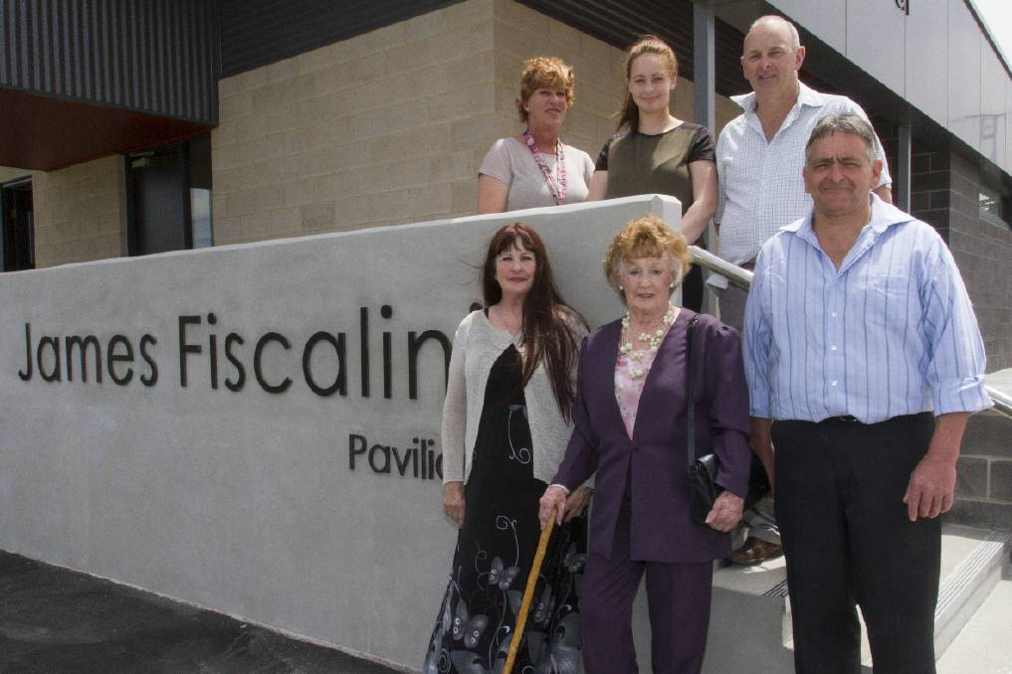

 The Fiscalini family - Donna, Perri and Ross, Chris, Heather Bennett and Peter Fiscalini - gather at the new James Fiscalini Pavilion, which is in honour of the for Ararat Rural City gardener.

Just as the previous building was, this section of the new building will continue to be known as the James Fiscalini Pavilion in recognition of the former Ararat Rural City gardener, who was instrumental in constructing and then maintaining Alexandra Oval.

The multi-purpose community space can seat 200 people, and features meeting rooms, an office space, a commercial kitchen, bar, canteen and trophy display cabinets at the main entrance.

It is estimated that in excess of 27,000 people will use the facility on an annual basis in a mixture of sports, celebrations, conferences, events and community activities.

Ararat Rural City CEO Andrew Evans said to cater for the demand Council had advertised for positions and selected an advisory group in recent weeks.

"Council is actually running the facility, so we have a Facility Coordinator who has been appointed and their job is to maintain, run and coordinate amongst the clubs the use of the facility," he said.

"The User Group is really positive, they are made up of representatives from each football club (Ararat Rats and Ararat Eagles), from the Grampians Cricket Association, from the community and Council and already they are all working very well together."

The centre won't be ready for public usage until January 1, 2015 however a public open day is being organised for the coming weeks, along with a 'test function' just prior to Christmas.

**Alexandra Oval – a history of users and facilities**

|  |  |  |
| --- | --- | --- |
| *Chronology* | | |
| 1858  January | **CRICKET GROUND.**  A grant of 10 acres, for playground, has been made to the Ararat Cricket Club.  The ground is in the neighborhood of the Green Hills. (near Green Hill Lake????) | |
| 1864  April | **GOVERNMENT GAZETTE**  The council of the Borough of Ararat to be trustees of the land reserved on the 4th March, 1861, for purposes of public recreation at Ararat. | |
| 1885  April | **LADIES’ STAND AT RECREATION RESERVE**  From the council minutes – J Nuzum’s contract for the erection of a ladies’ stand at the Recreation Reserve was completed, and certifying to the payment of £66 5s.  The total cost of the stand had been £93 16s. The council had received the money promised by the cricket tournament. | |
| 1902  March | **TENDER RESPONSE FOR APPLICATIONS FOR NEW GRANDSTAND**  5 competitive designs were received by the Borough Council for the new grandstand at the Recreation Reserve. | |
| 1902  August | **GRANDSTAND TENDER ACCEPTED`**  The tender to build a new grandstand at the Recreation Reserve from Mr WF Allen, Horsham, of £488 12s and 6d was accepted | |
| 1902  December | **OPENING OF NEW GRANDSTAND AT RECREATION RESERVE**  Mayor, Cr Wild, decided to invite the Ballarat City Council to the opening of the new grandstand at the Recreation Reserve. | |
| 1912  January | **PRETENTIOUS SCHEME FOR ARARAT – COMBINED OVAL FOR SPORTS – THE LARGEST IN THE STATE.**  A deputation to the Borough Council, including representatives of the Agricultural Society, Gardens Improvement Committee, Traders’ Association, Ararat Athletic Club, Football Club and Cricket Club proposed to provide the largest oval in the state. The matter has been taken up with great spirit by practically the whole town. | |
| 1912  March | **GRANT TO ARARAT RECREATION RESERVE**  The Government granted £10 for the improvement of the Ararat Recreation Reserve on condition that £5 be locally contributed. | |
| 1913  January | **CONSENT WITHDRAWN FOR NEW RECREATION GROUND**  After previously approving the plan of the Athletic and Football Clubs, Agricultural Society and Gardens Improvement Committee for a recreation ground adjoining the park, the council withdrew consent after ratepayers expressed disapproval by a majority of one at a poll taken. | |
| 1914  January | **ARARAT RECREATION RESERVE**  Ararat council discusses the cost of renovation of the Ararat Recreation Reserve. | |
| 1919 | **DEMAND FOR A BETTER SPORTS OVAL**  The return of the men from war in lead to a revival of outdoor sport demanding a bigger, better and more central oval than the Recreation Reserve | |
| 1919  April | **ARARAT NEW SPORTS GROUND - THE STATE PREMIER’S VISIT**  The State Premier, the Hon. H S W Lawson, MLA. expressed a keen desire to assist the Borough Council in every way possible in carrying out the proposal for a new sports ground abutting Alexandra Park on the west side. The council had wisely decided to expend the £749 voted by the Commonwealth Government to provide work for the soldiers. | |
| 1919  April 7th | **ARARAT’S NEW SPORTS GROUND – PUBLIC MEETING AT TOWN HALL**  A public meeting was held at the Council Chambers, Town Hall to make arrangements for the carrying out of the scheme of making a new sports ground abutting the west end of Alexandra Park. | |
| 1920  September | **GRANDSTAND TO BE SHIFTED**  The grandstand at the Recreation Reserve is to be shifted, in about 2 weeks time, to the new Sports Ground in readiness for the opening on Boxing Day. | |
| 1920 December 27th | **ARARAT’S GALA DAY – OPENING ALEXANDRA SPORTS GROUND – ATHLETIC CLUB MEETING**  Boxing Day was a red letter day in the history of Ararat, when the New Sports Ground at Alexandra Park, on which so much laudable public effort has been expended, was officially opened by the State Premier, the Hon HSW Lawson.  Like the Alexandra Gardens development volunteer labour was outstanding. 70 working bees with 270 attending one of these. £1650 was contributed in voluntary labour, and donated materials, etc, out of a total of £4600. | |
| 1921  May | **SCOREBOARD**  The Sports Ground committee rejected a price of £8/10/6 from McArthur and Son to erect a new scoreboard. It was decided to remove the scoreboard from the Recreation Reserve and put it into good order.  **GOAL POSTS**  It was resolved to erect goalposts to take in the full ground – Oregon, £20 | |
| 1921  October | **TURF WICKET**  The Ararat Cricket Association made a report to lay a turf wicket. | |
| 1921  December  26th | **NEW DRESSING ROOMS OPENED**  Federal member Mr WG Gibson, MHR opened the dressing rooms at the Boxing Day Athletics carnival. The cost - £500, built by TA McArthur and Son. It is a large ornate structure. It is a handsome indispensable adjunct to the conveniences of the reserve. | |
| 1923  July | **CRICKET PITCH QUAGMIRE**  The cricket pitch was a regular quagmire. It was too large and detrimental to football. There was room for 4 wickets. | |
| 1924  July | **CONCERN ABOUT MAINTENANCE EXPENDITURE ON THE OVAL.**  Over the last 9 months expenditure was £391 (£50 loss). It was moved to call a public meeting.  **IMPROVEMENTS CONTINUE**  Good drainage work is a great improvement for ground | |
| 1924  May | **GROUND IMPROVEMENTS**  Old publican’s booth to be moved to grandstand enclosure and converted into bandstand. | |
| 1920s-1930s | **COMMUNITY SUPPORT FOR THE SPORTS GROUND**  Various community groups held bazaars, community singing and dances to raise money to pay for further ground improvement and reduce ground debt. | |
| 1925  June | **ATTEMPT TO STOP THE SALE OF LIQUOR AT ALEXANDRA SPORTS GROUND**  The Women’s Christian Temperance Union is endeavouring to stop the holding of public booths at the Alexandra Oval Sports Ground. They recently out tendered the highest public booth offer to hold their own booth. | |
| 1926  May | **SPORTS GROUND IMPROVEMENTS**  It was resolved to carry out extensive improvements on the terrace at the foot of the J-Ward hill for the purpose of providing more accommodation for motor cars. Ararat is the only provincial town to permit cars in the reserve. | |
| 1926  June | **SUBWAY TO OVAL**  There is a preference to put in a subway under the railway, rather than a bridge, to lead to the oval. | |
| 1926  November | **CURATOR RESIGNS**  Mr J Howie, curator since the starting of the fine grounds, has been appointed to Footscray parks and gardens.  Mr J Fiscalini has been appointed curator to the Alexandra Sports Ground | |
| 1928  January | **ARARAT SPORTS GROUND LOAN FOR MORE IMPROVEMENTS**  Increasing costs to improve oval. | |
| 1928  August | **INTENTION TO PLANT AN AVENUE OF PLANTS AND SHRUBS**  The Alexandra Sports Ground committee decided to reclaim a portion of land abutting the reserve with a view to making the approaches more attractive.  **ELECTRIC LIGHT FOR ALEXANDRA SPORTS GROUND** | |
| 1929  July | **REVENUE SHORTFALL**  Owing to no senior football this year the Alexandra Sports Oval Committee will close £150 short this year. *(Ararat Football Club sat out of football as they were not accepted back into Wimmera football after leaving the Ballarat Football League – clubs were upset that Ararat had left the Wimmera competition in 1925)* | |
| 1931  January | **OVERDRAFT HAS TO BE REDUCED**  At a public meeting it was said “without doubt the Sports Ground was in most serious straits, and this must be got over.”  The Borough Council had previously recognised the committee’s claim and had move to pass them £100.  Bankers had told the Sports Ground Committee that a reduction had to be made in the overdraft.  Money was tight in the town – the hospital, the football club and now the Sports Ground Committee were each considering organising community singing as a revenue raiser.  Revenue was down as wet weather had impacted on the fixtures of the Athletics Club and Trotting Club, revenue from Patriotic Pictures was now divided with the hospital, and there had been no senior football in 1929. | |
| 1932  December | **DEPUTATION ASKS COUNCIL TO TAKE OVER SPORTS GROUND.**  A deputation of sporting bodies has asked the Borough Council to take over the sports ground.  Around £12000 has been expended and the debt is between £500 to £600. The council is willing to do so after viewing a full list of liabilities. | |
| 1933  January | **COUNCIL TO TAKE OVER CONTROL OF SPORTS GROUND**  At a special meeting of the Borough Council it was decided to take over control of the grounds, on which there is an overdraft of about £550. Expenditure by the Sports Ground Committee is to cease. The curator is to be given a week’s notice. | |
| 1932  February | **CURATOR APPOINTED**  Mr James Fiscalini was appointed curator of the Sports Ground by the Borough Council. | |
| 1933  June | **PRESS BOX TO BE BUILT AT ALEXANDRA OVAL**  Wimmera scribes will hear the news with great pleasure, as the reporting of a match from the grandstand, with the shouting of juveniles in one’s ears and the absence of even a desk to rest a book on makes the task a tedious one. | |
| 1947  September | **RECREATION RESERVE RE-NAMED**  Council re-named the Recreation Reserve as Kokoda Park. | |
| 1956  August | **LAST MINUTE MOVE TO IMPROVE DRAINAGE BEFORE WFL SEMI-FINAL**  Council attempted to improve drainage at the oval in the weeks before a WFL semi-final by installing new pipes the length of the ground. The works were halted after half the job was completed as they encountered sludgy conditions in the middle of the oval. | |
| 1956  August | **ALEXANDRA OVAL TO BE TOP-DRESSED WITH SEWAGE TREATMENT WORKS SOIL**  The Alexandra Oval will be top-dressed with sand and rot with soil from the sewage treatment works to try and improve drainage. “The topsoil will be a wonderful stimulant to the growth of grass.” | |
| 1959  March | **TENDERS FOR NEW OVAL CLUB ROOMS CLOSE LATER IN MONTH**  The City Council may guarantee to have the dressing rooms at Alexandra Oval removed and ready for an immediate start on the construction of modern club rooms for the Ararat Football Club.  The Football Club was willing to accept inconvenience in order to have the new rooms erected as quickly as possible. | |
| 1959  April | **VARIATION OF** £**1900 IN CLUBROOM TENDERS**  Four tenders, ranging in price from £6671 to £4738, have been received by the Ararat Football Club for a modern brick veneer club rooms at Alexandra Oval.  Football Club secretary, Mr RJ Falla said “We have done the job the council requested us to do by having plans and specifications prepared and calling tenders”. | |
| 1959  April | **MR JAMES FISCALINI RETIRES AS OVAL CURATOR**  Mr James Fiscalini retired as Alexandra Oval curator after 33 years and helped change it from a bare oval into one of the most attractive sports grounds in Victoria.  **CLUBROOMS GO TO CENTENARY PARK**  Messrs E Nunn and Son who started moving Ararat Football Club’s training rooms on Thursday morning and had the 60 by 30 front building on the move by Friday morning. The building is to be erected at Centenary Park. | |
| 1959  May | **BANK FINANCES OVAL PAVILLION**  Mr HP Peters, manager of the Ararat branch of the State Savings Bank of Victoria, has announced that the bank had granted a loan of £2000 to the City of Ararat.  The loan will be repayable over a period of ten years with interest at the rate of 5 and a half per cent per annum and will be used to finance the erection of a new brick dressing pavilion at the Alexandra Oval. | |
| 1959  December | **FISCALINI PAVILLION WILL BE THE BEST IN THE WIMMERA**  Claims by the councillors and football officials that the James Fiscalini pavilion at Alexandra Oval is the best in the Wimmera are not without foundation.  The spacious brick veneer building expected to be completed by early December, has every facility necessary, not only for football but for every sporting organisation using the oval.  It is a fitting building to grace the fine setting of Alexandra Oval, and unlike other pavilions has an off season use.  Built by SL Phillips and Sons for £4800, it stands as a monument to James Fiscalini whose work as a curator of the grounds was always readily extended in the interests of all who used them, and who still lives to proudly see the pavilion in use.  Towards the cost the Football Club contributed £2000, of which over £400 was raised by special effort in conjunction with the Trotting Club, and by the sterling work of the ladies’ committee.  Now these bodies are working for further additions to add value to the pavilion.  **The Building**  Two double doors centre the front of the eastern side of the building, opening off a wide concrete verandah running the full length and set off with bricked-in flower box.  The main hall, approximately 60 by 30 feet, will be divided by folding doors, providing for two dressing rooms.  Provision is made for separate showers and conveniences at the western end and off the main room is a wide tiled bath capable of holding four persons.  Four large windows, two on the wall, give ample natural light and a stone faced fireplace is set in the eastern wall between the first window and double doors.  A kitchen, administrative office and property office with ceiling to floor storage, are included in the building. The kitchen is fitted with ample cupboard space and hot and cold water, and the first aid room has a separate outside door for easy access to ambulance.  Main hall and offices are lined with Masonite from the floor to four feet, then plaster to the ceiling.  The whole structure is due to combined efforts of three clubs and the football ladies’ committee and will stand to the credit of Ararat generally for years to come. | |
| 1960  January 29th | **A MONUMENT TO A LIFETIME OF WORK**  “I trust that those who use this building will regard it not so much as a dressing room but as a monument to a lifetime of work by a mighty man – James Fiscalini”. That was said by the president of the Ararat Football Club, Mr Len Ford on Friday night before handing the keys of the James Fiscalini pavilion to the Mayor of Ararat, Cr RA Blachford.  Both the Mayor and the club president expressed a sense of indebtedness to the ladies’ committee of the Ararat Football Club, the Ararat-Stawell and Districts Trotting Club and Highland Society for contributions which helped to make the pavilion possible.  He thanked the architects who designed the building, and the builders, Messrs SL Phillips and staff, who did an excellent job.  “I have much pleasure in accepting the key from the president of the Ararat Football Club” Cr Blachford said.  This represents a really good combined effort by sporting bodies, with the greatest credit to the Football Club ladies’ committee whose efforts over the years raised a considerable sum of money, enabling the club to go ahead with the project.  The Football Club knocked on the door of the Government and they spared a little finance, the City Council added something and the Trotting Club and Highland Society joined in.  Cr Blachford  He believed the building was equal to any sports pavilion of its size in Australia. It was in keeping with the sports ground, for which much credit goes to Mr Fiscalini. | |
| 1962  November | **NEW GRANDSTAND SUGGESTED**  The City Council is to investigate a new Alexandra oval grandstand with totalisator, kitchen, dining room and offices. The grandstand is in a deplorable state and would need replacement before long and night trotting was a great attraction. | |
| 1969  October | **SPEED IS NEEDED ON OVAL WORKS FOR BIG CRICKET**  The following was discussed at an Ararat City council meeting: - a visit by a touring New Zealand team prompted a high-speed design programme of improvements at Alexandra oval. A dollar for dollar grant up to $10,000 would be available.  A city council sub-committee was appointed to investigate work necessary to upgrade facilities at the oval up to the required standard. (Cr D Rosengreen, Cr R Blachford, Cr R Blizzard, Town Clerk Mr J Grenfell and City Engineer Mr N Baldy)  The match will take place at Alexandra oval on January 3rd, 1970.  The facilities needed were – a suitable dining room, the existing dining room under the grandstand was a “shambles”. It is not reasonable to have the Fiscalini pavilion as a training quarters and use it as a dining room.  There was a suggestion to design the dining room in a manner to allow the addition of a grandstand at a later date. It was proposed to start with the kitchen and work up to the grandstand.  The structural elements of the grandstand were still alright - there was a lot of life in the main frames. Difficulties were met with the flooring and hand rails. | |
| 1969  November | **SPECIAL GRANT WORKS AT OVAL APPROVED**  At a City Council meeting it was moved that a new kitchen and dining room facilities will be provided at Alexandra oval in time for the cricket match against the touring New Zealand team.  A sketch plan was presented   * kitchen 30 feet x 20 feet * Dining room 40 feet x 20 feet, sit down accommodation for 100 people * Concrete floor, surrounding and dividing wall in brick * Kitchen fitting based on gas   It will replace the existing skillion building at the rear of the grandstand.  The new building is designed to allow progressive improvement of the grandstand.  Cost about $10,000 (half of grant plus council contribution) | |
| 1969  November | **MIRACLE IF OVAL FACILITIES ARE READY FOR NEW ZEALAND MATCH**  At an Ararat City Council meeting the City Engineer, Mr N Baldy, said it would be a miracle if the kitchen and dining room improvements at the oval would be completed in time for the cricket match against New Zealand. The plans and specifications had been simultaneously submitted to the Premier’s Department and Commission of Public Health. Cr G Moore said if the Premier was contacted these plans would get a kick along. | |
| 1970  January | **NEW ZEALAND CRICKET GAME CANCELLED**  Rain lead to the cancellation of the touring cricket match. | |
| 1970  December | **TOILET BLOCK FOR ALEXANDRA OVAL**  Construction of a toilet block could proceed next year if council receives a further $2000 from the Municipal Assistance Fund – matched with $1000 from council. Construction would proceed in May or June 1971 | |
| 1971  March | **OLD SHOW FACILITIES TO BE CLEARED**  Dilapidated buildings and stalls, formerly used by the Agricultural Society, and noxious weeds will be removed from the area adjacent to J Ward. | |
| 1971  April | **GRANDSTAND NEEDS REPAIRS**  The grandstand is in a dilapidated, if not verging on dangerous, condition and flooring was in a deplorable state. One of the front posts has dropped several inches and the whole of the woodwork needs painting. A plan is needed to renovate the building, Cr EW James said, after commending the new work which had been carried out by a special grant.  Reporting on special grant works City Engineer Mr NW Baldy said the construction of concrete plats in the open section of the grandstand was now about 20 feet short of completion and three short handrails would then be erected. The previous garden area in front of the grandstand will be gravelled and sealed.  *(by the end of 1971 wooden slats on metal frames were erected on the concrete plats)* | |
| 1971  July | **GRANT FOR RECONSTRUCTION OF GRANDSTAND**  Ararat City Council has received a $10,000 grant for the reconstruction of the grandstand and other facilities at Alexandra oval. Council had put the work in hand when the grant was promised by the government after the allocation of an international cricket match on the Ararat oval. | |
| 1971  November | **EASTERN TOILET BLOCK COMPLETED**  A photo in the Ararat Advertiser publicised the recent completion of the cream brick toilet block on the eastern side of Alexandra oval. | |
| 1971  ???? | **GRANDSTAND REPAIRED details???** | |
| 1971  ???? | **EASTERN TOILET BLOCK COMPLETED** | |
| 1973  March | **EXTRA LIGHTING FOR OVAL**  A second set of floodlights are erected on the eastern side of oval opposite an existing set of lights.  It is a 60 foot pole with three 1500 watt quartz-iodine, the lights mounted at 50 feet. Cost $500.  The first set of lights was installed a few years ago. | |
| 1978  December | **ARARAT COUNCIL BUDGET FOR OVAL**  At a council meeting $7,000 was budgeted for Alexandra oval projects. | |
| 1980  September | **NEW ENTRANCE FOR ALEXANDRA OVAL**  Council improved the entrance to Alexandra oval by constructing a ticket box in the middle of a median strip separating in-coming and out-going traffic. | |
| 1982  April | **GRANDSTAND NAMED**  After a recommendation from the AFC the Alexandra oval grandstand has been named the Olver Stand after Ararat Football Club stalwarts Mr Bill ‘Buff’ Olver and Mrs June Olver. | |
|  | **Bill ‘Buff’ Olver**  AFC Life member 1962  AFC player 69 games, 1946-49, Players’ Rep 1948  AFC Committee 1954  AFC Vice President 1955-62, ’66  Trainer 1963  AFC President 1967-69  AFC Secretary 1972-77 | **June Olver**  Life member - Ladies’ Committee 1963, AFC 1980  AFC Ladies’ Committee 1947-59, 1961-63  Secretary 1960, 1973-97  Assistant secretary 1964-66  President 1967-71  Treasurer 1972  AFC General Committee 1983-1997 |
| 1982  June | **NEW ROOMS OKAYED BY COUNCIL**  City Engineer, Mr Robert John, said after talks with the AFC executive it was proposed to build rooms adjacent to the southern end of the Fiscalini pavilion. It would be elevated and be 20 by 12 metres in area. Estimated cost $66,000. | |
| 1985  May | **NEW SCOREBOARD FOR OVAL**  Council erected a new scoreboard to replace the decaying old one.  *The old one was re-located to the Ararat Technical School oval*. | |
| 1992 | **ST MARYS NEW HOME GROUND**  St Marys Football Club made application to Council to share Alexandra Oval as a home ground with Ararat Football Club because of the poor facilities at Centenary Park. As the Wimmera FL and ADFA draws had already been completed St Marys weren’t able to play all home games at Alexandra Oval.  St Marys are to work around Ararat Football Club’s pre-season, in-season training schedules and WFL draw. | |
| 1993  March | **RENOVATIONS TO FISCALINI PAVILION**  The back portion of the Fiscalini Pavilion was demolished then new showers, toilets, gymnasium and football umpires’ room were added. Jim Pearce, builder and President of Ararat Highland Sports Society supervised the Ararat City Council $30,000 funded project. Completed in time for the Ararat Gift. | |
| 1993  May | **TOILET FOR THE DISABLED**  A toilet for the disabled will be added to the existing western toilet block behind the Olver Stand.  The cost of $4800 will include a path from the carpark. | |
| 1994  June | **LIGHTING TO BE UPGRADED**  Ararat Football Club received a $2500 grant from Council to be matched by $2000 from user groups to erect one new light pole. The current poor lighting meant clubs tended to train on one side of the oval which would lead to deterioration of the ground. The Ararat Football Club had investigated lighting (about $40,000) good enough to play night football and benefit other major events. | |
| 1994  August | **CONTINUED LIGHTING UPGRADE**  Council will meet with the AFC to further discuss options for further lighting improvements. | |
| 1995  November | **NEW KIOSK**  A new kiosk attached to the grandstand is nearing completion. It will overcome the need to serve food from a caravan or rotunda. It has been erected with the help of New Work Opportunities scheme and user groups. | |
| 1995  July | **NEW LIGHTING**  Three new light poles have been erected to carry the new lighting, adding to a pole set in place last year. | |
| 1996  October | **TREATED WATER USED FOR IRRIGATION**  Grampians Water will open the Ararat Wastewater Treatment Plant to the public as part of National Water Week. Alexandra Oval is one of the recipients of treated waste water for irrigation purposes. | |
| 2006  MONTH? | **WORK BEGINS ON FOOTBALL AND CRICKET CLUBROOMS**  Ararat Eagles Football Netball Club and the Grampians Cricket Association went in partnership to build shared clubrooms. | |
| 2007  January | **NEW SOCIAL ROOMS BURNT DOWN**  The Ararat Eagles Football Club/Grampians Cricket Association Social clubrooms were suspiciously burnt down before they could be officially opened. | |
| 2010 | **A BRIGHTER FUTURE FOR OVAL**  A state of the art lighting upgrade at Ararat’s Alexandra Oval means that State, or even national level sporting events can now be held in the municipality.  Last year Council installed four, 25 metre lighting towers with 24 2000 watt lamps, raising the facility’s lighting to 100 lux, the Australian standard for club football.  The new lighting was funded using $100,000 of the State Government’s $300,000 Local Works Infrastructure Program funding for drought affected communities.  Council is now in the process of delivering on stage two of the project, by installing two more lighting towers, at a cost of $80,000.  Council will split the cost with Ararat Community Enterprise, an independent organisation that has chosen the Alexandra Oval Master Plan as its major community project. Ararat Community Enterprise, through its business partners (Bendigo Bank, WFI and Community Telco) put money back into community projects. | |
| 2013  March | **ALL SYSTEMS GO FOR ALEXANDRA OVAL**  Ararat's sporting community is celebrating following yesterday's announcement of a $1.15 million funding boost to develop the new multi-purpose pavilion at the Alexandra Oval Community and Recreation Centre.  In Ararat yesterday, Minister for Sport and Recreation Hugh Delahunty said the funding was part of a Victorian Coalition Government facility funding package for the popular sporting precinct.  Mr Delahunty said the project would replace the existing outdated change-rooms with bigger and better change-room facilities catering for football, cricket, netball, umpires and match-day requirements.  "It will also involve construction of a multi-purpose community space, meeting room, function space, commercial kitchen, canteen, first aid room and public amenities," Mr Delahunty said.  "I congratulate the Ararat Rural City Council for developing the project and their investment of $2 million, as well as the Ararat Community Enterprise for their contribution of $100,000 and the Alexandra Oval Reserve Committee of Management for their contribution of $70,000. | |
| 2014 | **INTERIM CHANGEROOMS**  After being renovated the western toilet block behind the Olver Stand was used as change rooms for visiting football teams. | |
| 2014  November | **COMMUNITY AND RECREATION CENTRE AT ALEXANDRA OVAL HAILED 'ONE OF THE BEST OF ITS KIND' AT GRAND OPENING**  ARARAT and the surrounding districts are set to benefit for decades to come following the official opening of the new $3.8 million Community and Recreation Centre at Alexandra Oval.  Minister for Sport and Recreation Damian Drum has declared the state of the art facility to be one of the best sporting facilities of its kind in regional Victoria and said the redevelopment will have a profoundly positive impact on Ararat including attracting big events to the region.  "It has been built to a standard higher than just a community facility, so we will have the opportunity to host AFL practice matches and the like, this will be a regional centre for all sports.  Minister Drum was joined by Victorian Deputy Premier Peter Ryan and Senator for Victoria and Parliamentary Secretary to the Minister for Education, Scott Ryan, along with more than 100 members of the Ararat community at the grand opening on Thursday.  Ararat Football Club stalwart Harold Bright, 96, had the special honour of unveiling the commemorative plaque to mark the official opening of the multi-use facility.  Construction of the Alexandra Oval Community and Recreation Centre was made possible with funding from the Australian Government ($500,000 from the Regional Development Australia Fund), two grants from the Victorian Government ($650,000 from the Community Facility Funding Program and $500,000 from the Putting Locals First Fund), Ararat Community Enterprise ($100,000) and Ararat Rural City Council ($2 million, including the Alexandra Oval Reserve Committee of Management's $70,000). | |
| 2018  March | **GRANDSTAND RENOVATIONS**  Local builder, Andrew Eastick, was given the contract to do repair work on the Olver Stand. Both ends of the stand had dropped requiring new foundation work, steel girder and timber framework, and replacement of timber seat cladding above new works. Work completed in June. | |
| 2019  February | **OVAL FACILITY UPGRADE**  Old score board demolished, electronic scoreboard frame erected in the same place.  Gasons manufactured the frame. Installation by KHS contactors, West Cranes and Access Hire, Matt Peel Electrical, L & H Electrical suppliers. Tom & Logan North from Tom’s Mowing and Slashing dug the power cable trench.  Old coaches’ boxes removed from in front of the social rooms. New coaches’ boxes erected towards either end 50m line. | |
| 2019  April | **SCOREBOARD**  Electronic scoreboard trialled for the first time for Ararat Football Club intra-club practice match. | |

Dates to find:

Erection of western toilet block 1980s??

Erection of first oval lighting 1970-71??

Replacement of wooden benches at front of grandstand with red plastic seats and replacement of wooden flooring/seating in grandstand - after 1983??

Building begins on Eagles/GCA clubrooms 2006???

|  |  |
| --- | --- |
| **FOOTBALL at Alexandra oval** | |
| 1871 | **Ararat Football Club formed**  Up to 1920 played on grounds such as the Race Course, Cricket Ground (both near Green Hill Lake) and Recreation Reserve (now Kokoda Park)  Over the years other football clubs formed and were considered junior football clubs. |
| 1921  June 4th | **FIRST GAME OF FOOTBALL ON ALEXANDRA OVAL.**  Ararat Football Club 9.7.61 defeated Mount Gambier Rovers 5.13.43 |
| 1925  May 9th | **HOT SHOWERS AT ALEXANDRA OVAL**  The Ararat Football Club desired to install hot water showers at a cost of 15 pounds.  Asked the BFL if they could assist in any way.  Moved – the BFL granny 10 pounds towards the cost. |
| 1929 | **LOSS OF REVENUE FOR ALEXANDRA OVAL COMMITTEE**  In 1924 AFC moved to the Ballarat Football League for better competition. In 1929 AFC tried to re-enter the Wimmera competition but were not accepted by clubs who were unhappy that AFC had left in the first place. This meant a loss of revenue for the Alexandra oval committee. |
| 1958  November | **CITY COUNCIL TO HELP PROVIDE NEW DRESSING ROOMS AT OVAL**  The City Council will ask the Football Club and Trotting Club to prepare plans and specifications and call tenders for construction of new dressing rooms at Alexandra Oval.  Rough plans had been proposed by a builder whose firm estimate was £4500. |
| 1960  January | **AFC CANNOT CHARGE AT PAVILLION OPENING**  Permission has been granted the Football Club to officially open the “James Fiscalini” pavilion in Alexandra Sports Ground on Friday, January 29, but no admission charges can be made until the building is registered with the Health Department.  The club planned an official opening ceremony on the terrace fronting the pavilion, followed by a social and dance for which an admission charge was to be made.  Money received was to be put towards the cost of furnishings for the room. |
| 1960  December | **NO PAVILLION KEY FOR ARARAT FOOTBALL CLUB**  At its meeting on Monday night, Ararat City Council refused a request of the Ararat Football Club to have a key for the James Fiscalini pavilion issued to a responsible person.  Making the request, the club gave as its reasons that (a) as football club activities continue throughout the summer, regular committee meetings are necessary; (b) on many occasions and most weekends, old players and supporters returning to Ararat are eager to see the pavilion and photos and pennants are kept therein, and (c) it is felt, having contributed liberally to the cost of erecting the pavilion, the request was reasonable.  Cr de Clerq – “The Ararat Football Club does use the building a good deal and it may be difficult at times to get a key, but on the other hand there are other bodies that use it. If we do it for one, we must do it for all.” |
| 1962  November | **FOOTBALL COULD BE DENIED USE OF CLUBROOMS FOR MEETINGS**  Ararat Football Club could possibly be denied the use of its own club rooms for committee meetings, the James Fiscalini pavilion, towards the construction of which it contributed £2000.  A letter from Town Clerk, Mr Grenfell, said future applications for use of the pavilion must be forwarded in time to be presented at council meetings, otherwise your request will be refused.  Bob Falla jumped to his feet and declared “we are being treated like a lot of – I don’t like to use the adjective – school children. We have a £2000 equity in that building and we should endeavour to get the building as and when we like. I am fed up to the neck about the whole matter. |
| 1962  December | **PAVILION ACCESS GRANTED BUT NO KEY ISSUED TO FOOTBALL CLUB**  Pavilion access has been granted by the council at times when there are no other bookings, but not granted a key to use the building at will. |
| 1971  February | **AFC LADIES’ COMMITTEE REQUEST REFUSED**  Ararat Council refused an application from the AFC Ladies’ Committee to use the Fiscalini pavilion, kitchen and dining room facilities for catering purposes. |
| 1971  April | **AFC MAY SOON HAVE FOOTBALL HOUSE**  AFC committee man, Bill Studd, said at the moment the club relies on council owned facilities. It was vital for the club to gain its own clubrooms on its own land. It could be used as a gymnasium or catering for the ladies’ committee and other purposes. In time the club may get a liquor licence to produce extra finance. |
| 1973  December | **AFC GIVEN LAND ON CONDITION**  Ararat Council approved the application by the AFC for an area of land to the north of Alexandra Oval provided:   * Plans approved by the council to be submitted within 6 months * Proof of financial capacity to satisfactorily carry out the proposal within 3 years. |
| 1974  February | **CLUBROOM PLANS TO BE DISCUSSED**  Special meeting of the AFC to discuss development plans for proposed social clubrooms – advice to be sought from VFL clubs. |
| 1974  December | **$50,000 SOCIAL CLUBHOUSE FOR FOOTBALL CLUB**  At the annual meeting AFC gives go ahead for planned social clubrooms at Alexandra Oval. |
| 1975  August | **APPEAL FOR CLUBHOUSE**  AFC opened an appeal to raise $60,000 for a social clubhouse. |
| 1977 | **AFC PURCHASES LAND**  AFC paid $2,000 for land adjoining Alexandra oval and the Tennis club with a view to building social clubrooms. |
| 1982  March | **APPLICATION TO NAME GRANDSTAND**  At an AFC committee meeting it was moved that a recommendation be made to council that the grandstand be named the “Olver Stand”. |
| 1983  March | **ROOMS FOR CLUB**  The City Council made the decision to give control of the Olver Stand to the Ararat Football Club.  The club proposes to move the kitchen to one end of the area and put in arch ways so that the area will be large enough to accommodate the club’s social functions. Stairs are to be constructed up to the Olver Stand for watching football matches *(this was not constructed)*. It had been in the club’s plans since the mid-1950s for its own clubrooms.  **OLVER STAND COMMITTEE**  An Olver Stand committee is to be formed (from the AFC) with the function to construct and finance football clubrooms and to administer and provide financial reports to the AFC and Ararat City Council. |
| 1983  May | **AFC SELLS HOUSE**  AFC sold the house they owned in Clarke St for $19,000 |
| 1983  August | **AFC TO MEET WITH COUNCIL ABOUT FACILITIES**  The AFC will meet with the City Council to discuss netball viewing facilities, toilets under the Olver Stand and a new scoreboard. It will also ask the council to raise a loan of $30,000 on behalf of the club. |
| 1984  December | **AFC ACCEPTS COUNCIL’S OFFER OF ASSISTANCE**   * The AFC accepted the following offer from the City Council: * Provide $10,000 for construction of a new scoreboard and gatekeeper’s station. * Keep advertising signs up all year * Provide an interest free loan of $9000 until 30th September 1985 * Transfer ownership of land owned near tennis courts for gratis |
| 1985  March | **AFC LAND TRANSFERRED TO COUNCIL**  AFC transferred the land it owned to the City of Ararat for $1.  **OLVER STAND TOILETS TO BE COMPLETED**  New toilets are to be added on to the north end of the Olver Stand.  Quotes were accepted from R & L Loeliger - $19,700 and Cane Plumbing - $3,851 for a total of $23,551.  They are to be finished in 8 weeks. |
| 1986  September | **SHOWERS NEED UPGRADE**  AFC to contact Ararat City Council to seek extension and upgrading of Fiscalini pavilion showers. |
| 1986  November | **REQUEST REFUSED**  Ararat City Council refused AFC’s request to upgrade showers. |
| 1989  July | **BAR TO BE CONSTRUCTED IN OLVER STAND**  A sub-committee of the AFC was formed to construct bar facilities in the Olver Stand. Richard Harricks, Trevor McKinnis, Phillip Lugg and Greg Dadswell. |
| 1993  May | **RATS TAKE CHARGE OF FISCALINI PAVILLION**  On the recommendation of Henry Gunstone, Ararat Recreation Officer, the Ararat Football Club was made the committee of management for the Fiscalini Pavilion. The club is a major user of the facility. |

|  |  |
| --- | --- |
| **NETBALL at Alexandra Oval** | |
| 1972 | **ARARAT FC NETBALL CLUB FORMED**  Netball played on court on the south west corner of the hospital grounds (car park/ambulance station). Each week the netballers had to scratch netball lines onto the court surface. |
| 1972  July | **PROPOSAL FOR NETBALL COURT**  Council moved construction of a netball court at Alexandra Oval subject to a reasonable contribution from the AFC Netball Club. |
| 1973  October | **PROBLEMS WITH NEWLY LAID COURT**  Wet weather and speed of construction (to try and complete an asphalt court) lead to problems in the surface which needed patching. |
| 1985  April | **NETBALL COURT MAINTENANCE**  After a request from the AFC the Ararat Council re-seal the netball court at Alexandra oval. |
| 1991  Before season | **NETBALL SHOWERS CREATED**  With materials supplied from the Ararat City Council and volunteer work from members of the AFC 2 showers were constructed in the female change-rooms of the western toilet block behind the Olver Stand. |
| 2001  December | **NETBALL COURT RELOCATED**  After the AFC Netball Club had requested the re-surfacing of the netball court at Alexandra Oval, they were told funding would only be granted if they shifted to a safer location (short and sloping run-offs). Council Recreation Officer – Henry Gunstone was successful in gaining a $38,000 grant to green flexi pave over two existing black hot mix tennis courts and $8,000 grant to install lighting.  The eastern court doesn’t have enough run-off for Wimmera Netball to be played on.  *(Over the years there were concerns about the disconnect between netball and football facilities and young children having to walk through car traffic to get to and from the canteen)* |
| 2004 | **NETBALL SHELTER ERECTED**  Spectator shelter erected – financed by Ararat FC Netball Club. |
| 2017 | **CONCERNS ABOUT SAFETY OF NETBALL COURTS**  Netball goal circle surfaces became too slippery in the wet – in an effort to improve the problem incorrect paint made problem worse – eventually corrected. |
| 2017  August | **CLUBROOMS REMOVED**  The Ararat Eagles Football Club/Grampians Cricket Association clubrooms were deemed surplus to the reserve requirements and were shifted to the Ararat Hospital as a classroom for students. |
| 2018  March | **NETBALL COURTS RESURFACED**  Ararat Council budgeted $9000 to resurface the 2 existing netball courts to improve the grip. |

To find

Netball shelter 2004???

|  |  |
| --- | --- |
| **TENNIS at Alexandra oval** | |
| 1878  December | **TENNIS FIRST PLAYED IN ARARAT**  First court in corner of Recreation Reserve. |
| 1886  January | **NEW TENNIS COURT**  Permission to asphalt and control courts in the Garden Reserve – ground between Bowling Club and Croquet Club in High St. |
| 1909  January | **MAYOR OPENS NEW TENNIS COURT**  Mayor, Cr G Burn, opened the new and most up-to-date tennis court of the Ararat Tennis Club. |
| 1912  November | **MAYOR OPENS NEW TENNIS COURT**  Mayor, Cr G Burn, opened the new and most up-to-date tennis court of the Ararat Tennis Club. |
| 1914  May | **OPEN NEW COURTS**  The old court was taken up from the foundations and entirely remade after the latest design.  Messrs McLeod and Co of Geelong were the contractors. |
| 1923  January | **GRAMPIANS TENNIS TOURNAMENT**  The Grampians Tennis Tournament is held on Alexandra Oval over Friday, Saturday and Monday. Ten courts were marked out on the oval. “The turf is in excellent condition reflecting the greatest credit on the curator, Mr Jim Fiscalini.” |
| 1928  February | **MORE COURTS TO BE PROVIDED**  It was decided at a meeting of the Ararat Tennis Club that more courts and a more commodious and up-to-date clubrooms were necessary in view of the progress being made by the town. |
| 1929  October 5th | **CLUBROOMS OPENED**  Tennis club President, Mr HE Webb, opened the new clubrooms. The new pavilion (a residence moved from Dobie) was converted  at a cost of about £400. Members and visitors admired its comfortable spaciousness and simple but up-to-date appointments. The pavilion was erected mainly due to the efforts of the ladies. |
| 1931  October | **LAND SALE TO TENNIS CLUB**  The Alexandra Sports Ground Committee sold about an acre and a half (£200) to the Ararat Tennis Club to lay down a set of grass courts. |
| 1932  November 5th | **NEW TENNIS COURTS OPENED BY MAYOR CR WL BREWSTER and MAYORESS**  The whole scheme had been designed by Mr Robert Speed – who unfortunately died before being able to see the full accomplishment.  Winter and summer tennis can now be played under excellent conditions.  Tribute was paid to Mr J Fiscalini, curator of the Alexandra Sports Ground, for the excellent state in which the lawns were in.  Exhibition matches were played by four of the State’s leading players – Holloway, Fleming, Teague and Ryan. |
| 1933  February | **NEW LAND PURCHASED FOR CLUBHOUSE**  Ararat Council agrees to sell about half an acre of land adjoining the grass and asphalt tennis courts on which to erect a clubhouse. £13, £2 to be paid down and the balance in five years with interest. |
| 1933  Month???? | **TENNIS COURT CLUBROOMS**  The Ararat Tennis clubrooms from the old asphalt courts on High Street were removed to the new lawn courts. |
| 1933  August | **OLD TENNIS COURTS TAKEN OVER**  The Ararat Croquet Club has taken over the old courts of the Ararat Tennis Club and intends to lay down extra lawns. |
| 1934  January | **STALWART REMEMBERED**  A memorial sundial was erected to recognise the work of Mr Robert D Speed who was secretary for many years. |
| 1935  September | **SEASON OPENING**  2 new hard courts were put down in the winter and were now ready for play.  Under the excellent care of James Fiscalini the lawn courts had recovered from the grasshopper plague. |
| 1937  December | **MORE LAND PURCHASED**  The Ararat Council agreed to allow the Tennis Club to purchase an “eyesore” piece of land between the Tennis Club and the Sports Ground for improvement. |
| 1959  June | **FOOTBALLERS USE TENNIS CLUBROOMS AS CHANGEROOMS**  Due to the removal of old football change rooms and construction of the Fiscalini pavilion footballers changed in the Tennis club clubrooms. |
| 1965  June | **CLUB IN FINANCIAL DIFFICULTY**  Ararat Tennis club in financial difficulty as rates and water charges have doubled. |
| 1966  July | **SOLUTION OFFERED**  Minister rules Tennis Club ground as recreational  City Council asks the Lawn Tennis Club for their land title - this would save $190 in yearly rates and offered a sliding scale for water – this is rejected.  Tennis Club is using 1 million gallons of water yearly. |
| 1967  November | **HOPEFUL WATERING SOLUTION**  Tennis club bores for water to maintain their courts. |
| 1967  December | **WATER ROSTER**  A roster of members was drawn up to water the courts to ensure the grass survived the drought. |
| 1970 | **NEW TRUSTEES APPOINTED**  Mr Grant, Mr Lardner and Mr Richardson |
| 1979  January | **ALEXANDRA OVAL USED FOR TENNIS COURTS**  Due to the large number of entries at the ANA annual tournament extra courts were set out on Alexandra oval. |
| 1982  September | **CITY COUNCIL TAKES OWNERSHIP**  Following negotiations, the tennis courts now belong to the city of Ararat. |
| 1982  December | **NEW COURTS OPENED**  The tennis club constructed 4 new grass synthetic courts and lights. $20,000 to come from the Department of Youth Sport and Recreation, $20,000 from the city of Ararat and $15,000 from the tennis club. (350 junior members at this time) |
| 1983  January | **BORE WATER NOT THE SOLUTION**  Bore water, which is not suitable for the tennis courts is being used to keep the surrounds in good condition. |
| 1983  May | **TENNIS COURTS TO BE LEASED**  The City Council to give a 21 year lease of the courts to the Tennis Club. |
| 1983  Month??? | **NEW TENNIS COURTS**  Four new artificial grass courts with lights were established on the western side of the original clubhouse |
| 1989  November 19th | **NEW CLUB HOUSE OFFICALLY OPENED**  A brick clubhouse was constructed to replace the old weather board clubhouse. |
| 1996  December | $28,000 for new tennis courts – details ?? |
| 2006-2007 | Grass courts at the front were also reworked and surfaced with artificial turf.  Other surfaces were replaced in 2010 (western side) and (southern) in 2015. |

|  |  |
| --- | --- |
| **TROTTING CLUB at Alexandra Oval** | |
| 1920  April | **ARARAT TROTTING CLUB WAS FORMED** |
| 1921  June | **FIRST TROTTING MEETING AT ALEXANDRA OVAL**  A Programme of 6 events. £100 prize money. |
| 1935  August | **PROPOSAL TO CHANGE SHAPE OF TROTTING TRACK**  It has been proposed to do away with the oval shaped trotting track |
| 1947  April | **TROTTING CLUB RE-ORGANISED AFTER LAPSE OF 9 YEARS** |
| 1949  August | **PROPOSAL TO LIGHT UP ALEXANDRA OVAL TROTTING TRACK**  The Ararat Trotting club has decided to light Alexandra Oval. At present Ararat is only allocated 2 meetings a season. The club is hopeful the government will grant more country dates. |
| 1950  January | **NEW TROTTING CLUB FORMED**  The enthusiasm for night trotting resulted in the formation of Ararat and Stawell and Districts Trotting Club. The cost of lighting at Alexandra Oval will be about £3000 |
| 1950  March | **FIRST NIGHT TROTTING MEET AT ARARAT**  Second club outside Melbourne after Mildura to hold a night trotting meeting. Ararat’s venture is on a more elaborate scale and facilities, generally, are better. The fast and safe track is ideally suited for racing under lights, it is just under 3 furlongs, enabling a close up of the runners. |
| 1952  December | **TRACK ALTERATION**  The trotting club submits plans to reconstruct the Alexandra Oval trotting track. |
| 1953  February | **COUNCIL REJECT PLANS**  Council refuses plans to reconstruct the track as it reduces the width of the arena and takes in the entrance to the grounds. |
| 1953  May | **PROPOSAL TO RECONSTRUCT TROTTING TRACK**  2 straights of 140 yards, minimum radius of 174 feet  Shift the curator’s residence, take a portion of the hill, take in the camping ground, take a strip of the oval in front of the grandstand |
| 1953  July | **ANOTHER PROPOSAL**  8 yards shorter than present track, 93 yard straight (grandstand side) 111 yard back straight, take 10-12 feet of oval grandstand side, swing onto camping ground, take in camp kitchen, remove a number of mature trees, right up to hedge at curator’s residence, cut off the driveway to parking area near tennis courts. |
| 1953  August | **TROTTING CLUB MEETING WITH COUNCIL**  At a meeting the Trotting Club seemed dissatisfied with the Council Engineer’s trotting track plan. The club proposed to move the curator’s residence and discuss everything but the track. Cr Murphy felt they did not want a new track this year, but were prepared to wait three years for a better track. The next move was up to the Trotting Club. |
| 1955  November | **COUNCIL TO CHARGE CAR ADMISSION TO ALEXANDRA OVAL**  The Ararat-Stawell and Districts Trotting Club disagree with the Council proposal to charge admission for cars entering Alexandra Oval. The trotting club suggested to the council it wants 20 acres to develop its own track. A split in the club lead to the eventual development of a Stawell track. |
| 1955  December | **ARARAT STAWELL AND DISTRICTS TROTTING CLUB TO HOLD TROTTING MEETINGS AT STAWELL**  Decision made on the grounds that the club could never own council controlled Alexandra Oval. |
| 1956  May | **ARARAT COUNCIL OFFERS TO BORROW £3000 TO IMPROVE THE ARARAT TRACK**  Claims the Stawell track would be laid at no cost and a drive-in would be privately built to help finance the scheme. Ararat Council offered to improve the track. |
| 1956  July | **COUNCIL MEETS WITH TROTTING CONTROL BOARD**  The TCB refuses the Ararat Council’s request to guarantee that trotting will be held at Alexandra Oval over a number of years. The TCB also refuses to grant the council the right to hold meetings on the Alexandra Oval track. The bad state of the track was a concern to the TCB. It was appropriate to hold discussions with the Ararat-Stawell and Districts Trotting Club over the state of the track. |
| 1965  April | **PHOTO EQUIPMENT FIRST USED AT ALEXANDRA OVAL**  At the Easter Monday meeting of the Ararat-Stawell and Districts Trotting Club photo equipment was used for the first time. It worked perfectly and proved a great assistance to judges on a number of occasions to verify winners or place-getters. Photos were in the judges hand less than 2 minutes after the horses passed the post. |
| 1966  March | **TROTTING CLUB MAKES A REQUEST TO THE ARARAT COUNCIL TO WIDEN AND EXTEND THE TRACK**  The request was for a 50 feet wide track 3 and a half to four furlongs long. |
| 1966  April | **COUNCIL REFUSES REQUEST TO ALTER THE TRACK**  The track could not be laid without purchasing private land, heavy earthworks and slicing off 15 feet of the western side of the oval. |
| 1966  June | **THE TCB GIVES 12 MONTHS TO GET TRACK SAFE**  Until the track is brought up to standard Ararat meetings are only allowed 10 horse events at 5 abreast. |
| 1966  July | **$120,000 NEEDED TO CREATE A 4 FURLONG TRACK AT THE ARARAT RACECOURSE.**  The Chairman of Stewards said the Alexandra Oval track was unsafe for improved class fields and higher standard trotting. Developing a trotting track at the Ararat Racecourse was a good option. |
| 1966  August | **TCB SETS A NEW STANDARD LENGTH FOR TROTTING TRACKS**  The Trotting Control Board says the new minimum standard trotting track is 3 and half furlongs for a night track and 4 furlongs for a day track. |
| 1966  September | **TCB, ARARAT COUNCIL AND ARARAT-STAWELL AND DISTRICTS TROTTING CLUB AGREE ON NEW SITE**  The 3 organisations agreed that land at the North East Common off Campbell St was to be the site for the new Ararat Trotting track. |
| 1967  May 24th | **FAREWELL TROTS MEETING**  “The ovular track which served the Ararat-Stawell and Districts Trotting club for 17 years had been the venue of an authorised meeting for the last time. Labelled anachronistic by the Trotting Control Board Alexandra Oval will be replaced by the modern Russell T White Raceway.” |

|  |  |
| --- | --- |
| **ATHLETICS at Alexandra Oval** | |
| 1874  December | **FIRST BOXING DAY SPORTS IN ARARAT** |
| 1920  December | **BOXING DAY SPORTS AT THE OPENING OF ALEXANDRA SPORTS GROUND**  After the Premier opened the Sports Ground the Athletic Club held their athletics meeting. |
| 1926  August | **ATHLETIC CLUB TO LIGHT UP ALEXANDRA OVAL**  Council agrees with the Athletic Club intention to light up Alexandra Sports Ground by electricity. This would allow them to run their Boxing Day program into the evening. The club did not want Council money but the assistance of officials to help in erection work. They would like the Council Engineer to purchase 30 poles for them. |
| 1933 | **FORMATION OF HIGHLAND SPORT SOCIETY**  The Ararat Highland Sports Society was formed by a meeting convened by Mr J Robertson. Mr Alex McDonald was elected Chief. |

Dates to find:

Years the sports were not held

Different dates of meetings

|  |  |
| --- | --- |
| **ARARAT AGRICULTURAL SOCIETY at Alexandra Oval** | |
| 1863  March 12th | **INAUGURAL SHOW AT MARKET SHEDS**  In 1860 attempts to make Ararat a market town were initiated when more than fifty drays were bringing in farm produce each week. The Municipal Council built market sheds on the reserve gazetted for the purpose. The building was the venue for the Agricultural Society’s inaugural show. |
| 1937  April | **SHOW GROUND SALE**  The Agricultural Society ask permission to sell their show grounds before moving to the Ararat Sports Ground. |
| 1938  June | **NEW HOME FOR AGRICULTURAL SOCIETY**  The Ararat Agricultural Society shifted their buildings, for a cost of £900, from the old show yards (site of the former Prestige Mill) to the site between the Ararat Sports Ground and J-Ward. |
| 1938  November 11th | **FIRST SHOW AT THE NEW SHOW GROUNDS.**  Mr H Pye, MLC, assistant Minister for Agriculture officially opened the new show grounds, above the Sports Ground adjacent to J Ward, in the presence of a large gathering. |
| 1959  May | **DISCUSSION TO MOVE TO A NEW SITE**  The Ararat Agricultural Society is going to investigate the possibility of moving their buildings to another site which will give more scope for their activities so that at some future date the show may be enlarged. |
| 1968  June | **RECOMMENDATION TO MOVE TO RUSSELL T WHITE RACEWAY**  At a meeting of the Ararat Agricultural Society it was recommended that the Russell T White Raceway would make an ideal site for their activities if permission could be obtained from the Ararat Council and Trotting Club. |