Ararat Football Club Uniforms
1876 – ?  blue guernsey and knicker bockers  blue and white cap and grey stockings | 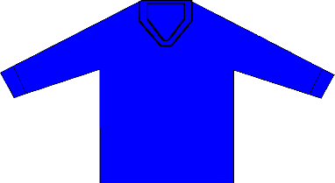 | 1880 – ? | 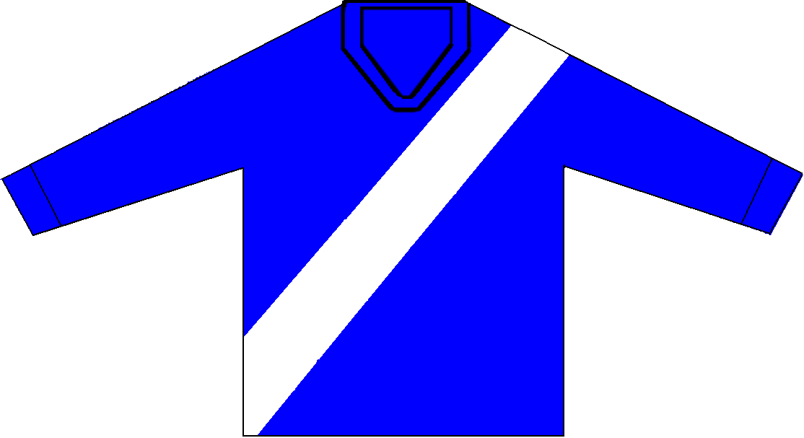
1890s - 1922 | 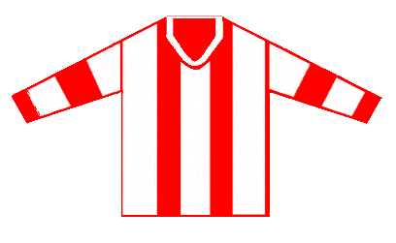 | 1923 – 1924  white shorts, red socks with white cuffs | 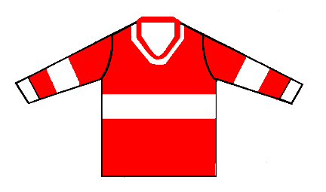
1925 – 1928  white shorts  black socks with white cuffs | 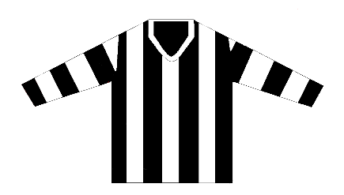 | 1930 – 1940  white or black shorts  black socks with white cuffs | 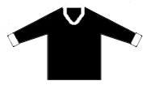
1946 – 1948  white or black shorts  red and white hooped socks  white back with red numbers | 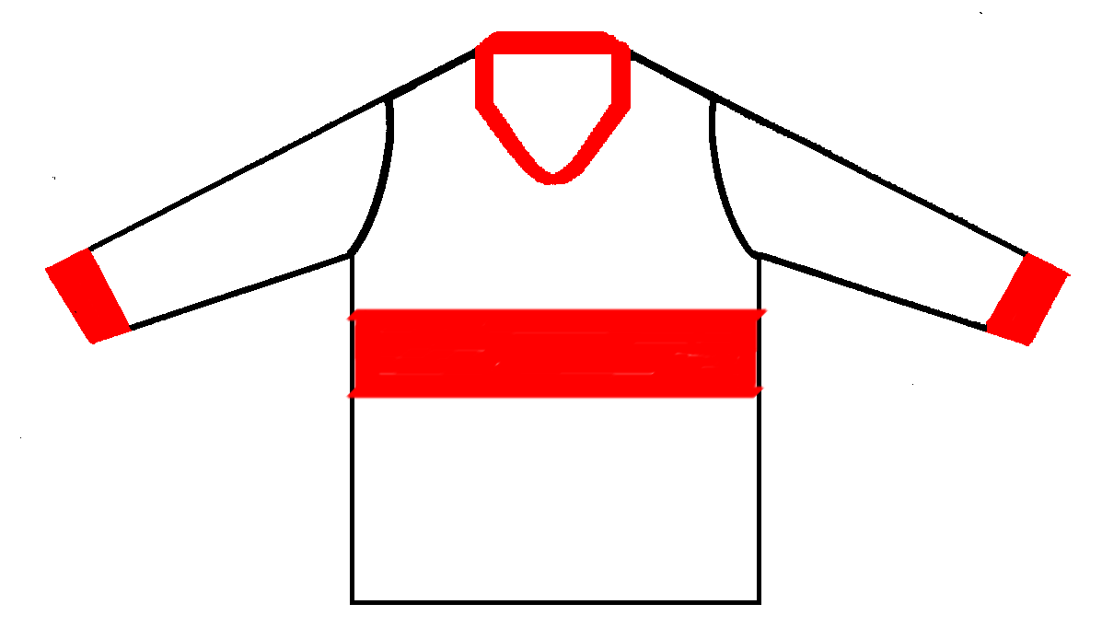 | 1949 – 1997  white or black shorts  (late 1970s red shorts)  red and white hooped socks  (late 1970s red socks)  white back with red numbers | 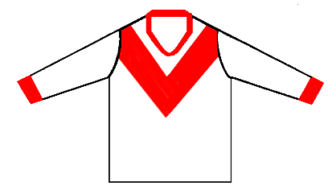
1998 – 2016  red or white shorts  red and white hooped socks  red back with white number | 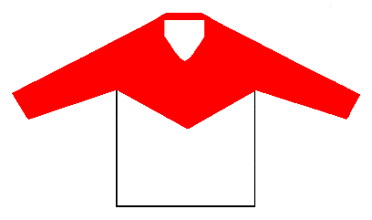 | 2017 – Current  Red shorts  Red and white hooped socks | 